Activity:
Multiple Variables and Modulo
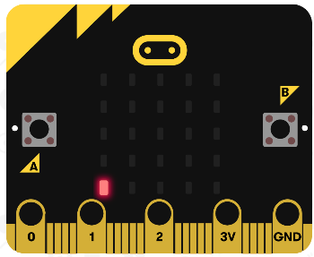
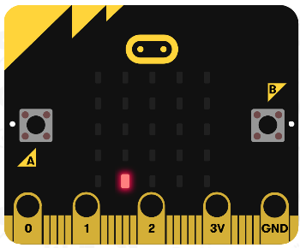
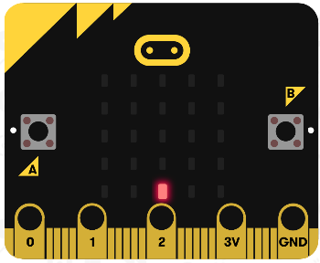
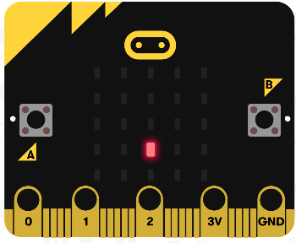
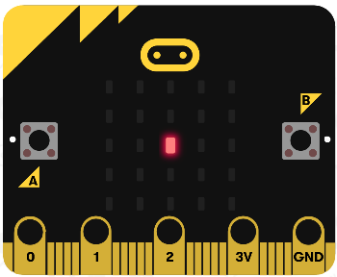

Description:
Build a program that will move an LED element around the display. The A button will be used to increment the y-coordinate by one and the B button will be used to increment the x-coordinate by one.

Vocabulary and Concepts:
Variable: a named location in memory that stores a value that may change
Data type: describes the kind of data a variable may store, the range of values, the allowed operations, and the amount of memory required.
Examples: Variables may hold numbers, letters, characters, etc.
Modulo: an operator that performs division and only keeps the remainder.
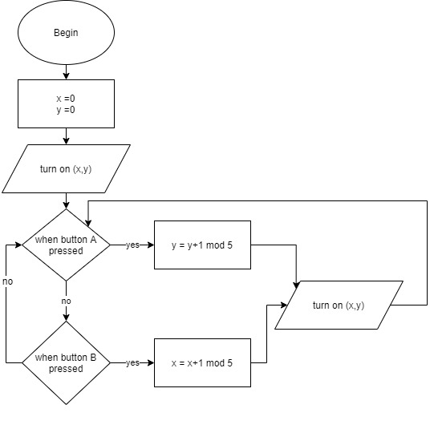
Flowchart:

Getting Started:

The LED screen
The micro:bit LED screen has 25 red LED lights arranged in a 5X5 grid (5 LEDs across by 5 LEDs down). Rows are denoted as x and columns are denoted as y.

Which LED?
You use (x ,y) coordinates to specify a particular LED in the grid; where x is the horizontal position (0,1,2,3,4) and y is the vertical position (0, 1, 2, 3, 4). To figure out the (x, y) coordinates, position your micro:bit horizontally.
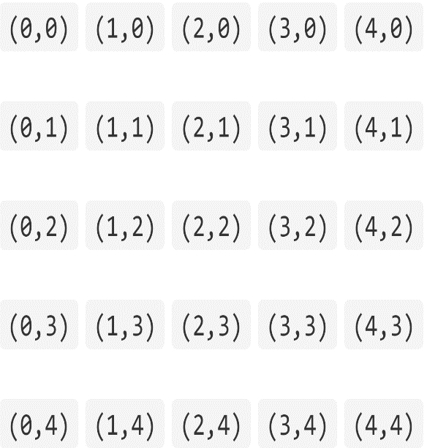
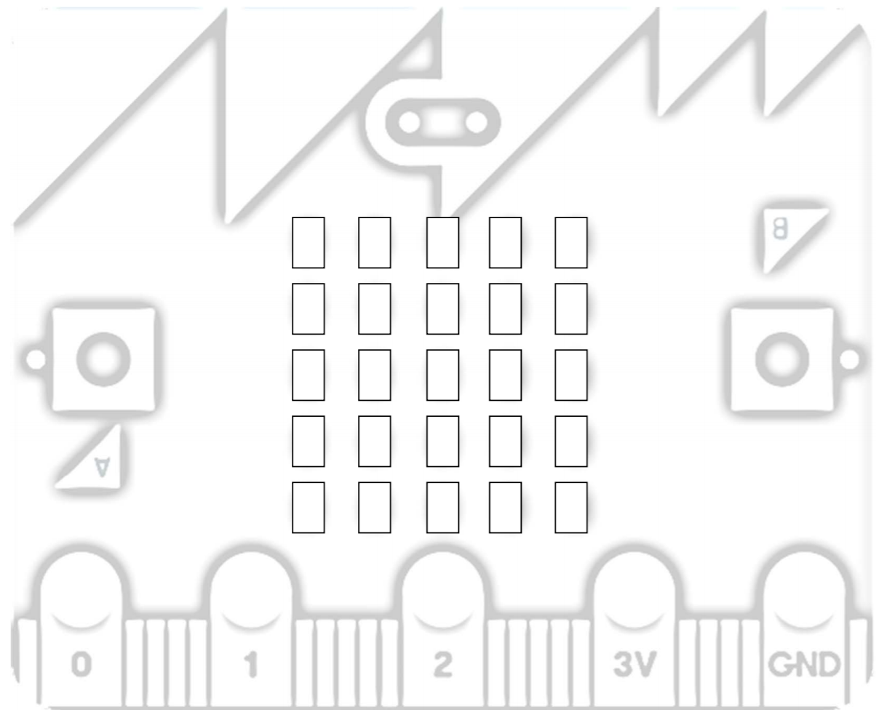
Here are the (x, y) coordinates for the LEDs in the 5X5 grid:

Row, column - 1
Since the row and column numbers start at 0, an easy way to figure out the (x,y) coordinates is to subtract 1 from the row and column number (when counting from 1). In other words, to specify the LED in the 4th column 5th row, subtract 1 from each number to get coordinates (3,4).

Understanding Modulo
The program you will create will need an operator that is used often in computer science, the modulo operator. Computer scientists often use modulo when they need to turn a big range of numbers into a smaller, repeating range of numbers. The modulo operator retains the remainder of the division of two numbers and discards everything else. Using squares is a great way to understand this operation.

Examples
- 4 mod 2: Shading two blocks at a time.
  - Step 1: Shade first two blocks

  - Step 2: Shade the next two blocks

  - Step 3: Can we shade any more blocks in groups of two? No
  - Step 4: Count any remaining unshaded blocks, there are zero. Therefore, 4 mod 2 = 0
- 11 mod 5
  - Step 1: Shade the first 5 blocks

  - Step 2: Shade the next 5 blocks

  - Step 3: Can we shade any more blocks in groups of 5? No
  - Step 4: Count any remaining unshaded blocks, there is one. Therefore, 11 mod 5 = 1

- 4 mod 7

  - Step 1: Can we shade any blocks in groups of 7? No
  - Step 2: Count any unshaded blocks, there are four. Therefore, 4 mod 7 = 4

Practice

- 12 mod 6

- 7 mod 5

- 12 mod 5

- 9 mod 12

Solving the problem:
Your teacher will now help you design a program to solve the problem outlined in the above description. Now that you know the algorithm(flowchart) and how modulo works, you have everything you need to solve the problem.

Congratulations!
You have learned to use variables!!

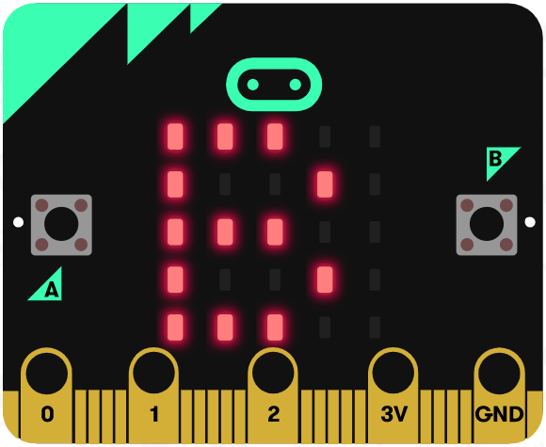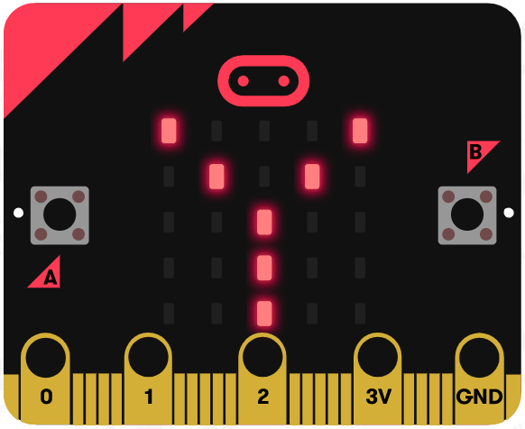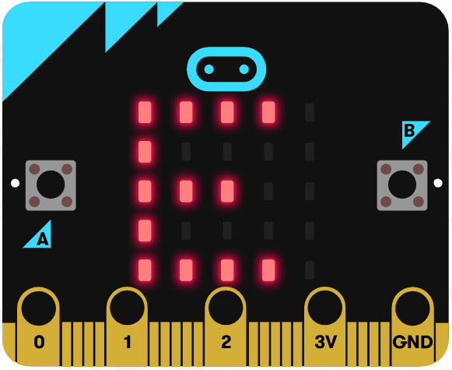

References
Online quick start tutorial: http://microbit.org/guide/quick/
Flowchart tool: https://www.draw.io/
Adapted from the following lesson: https://makecode.microbit.org/device/screen

