Activity:
Variables on the micro:bit

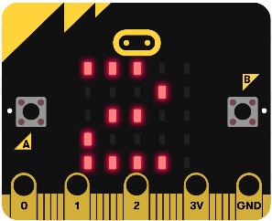
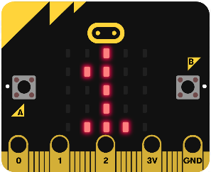
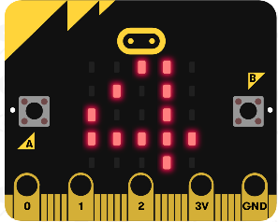
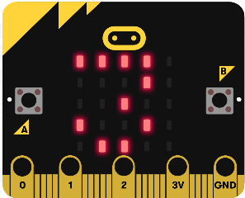

Description:
Build a program that will display nothing on the display on start. If button A is pressed, the display should output a “1” forever. If it is pressed again it should output a “2” forever, then if pressed again a “3”, then a “4”, etc. The goal is to create a counter.

Vocabulary and Concepts:
Variable: a named location in memory that stores a value that may change
Data type: describes the kind of data a variable may store, the range of values, the allowed operations, and the amount of memory required
Examples: Variables may hold numbers, letters, characters, etc.

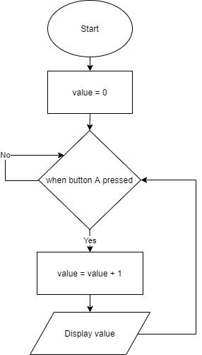
Flowchart:

Let’s Start Programming!

Introduction:
Variables are things that are remembered by the micro:bit. Variables can take a few formats and can have functions applied to them. For example, we could create a string, which is text. Or we
could create a calculator that stores whichever number the user inputs as an integer. We can modify variables, but they must first be defined.

Solving the problem:
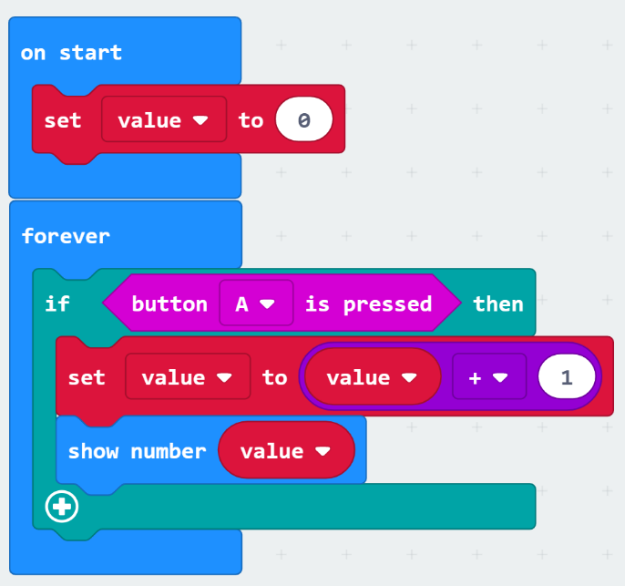
Begin by creating a variable, click the Variable tab and select “Make a Variable”. Drag the “set value” block and place in the “on start” block. The set item block allows you to set a variable to an integer value or the value of another variable. Make sure value is set to zero. We can also set value to something else using this line. For example, we could use the functions in the Math tab to set value to value + 1. If we combine this with the forever loop and if statements then we can create a counter. Click on the Logic tab and drag the “if then” block to the “forever” block. Replace the word true in the “if then” block by going to the Input tab and selecting the “button A is pressed” block. Next, grab another “set value” block and place inside the if statement. Replace the number in the “set value” block with an addition block from the Math tab. Make the second number a one and replace the first value with “value” which can be found in the variables tab. Finally, insert a “show number” block from the Basic tab. Replace the number with “value”.

What Does This Code Do?:
- We create a new variable called value and set it to 0
- The code runs forever and waits for the user to press the A button
- When the user does, value will be set to value + 1 (value will be incremented by 1)
- Value will then be displayed on the micro:bit's LEDS
- This effectively creates a counter

Congratulations!
You have learned to use variables!!

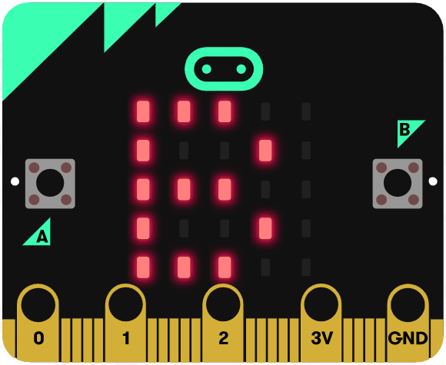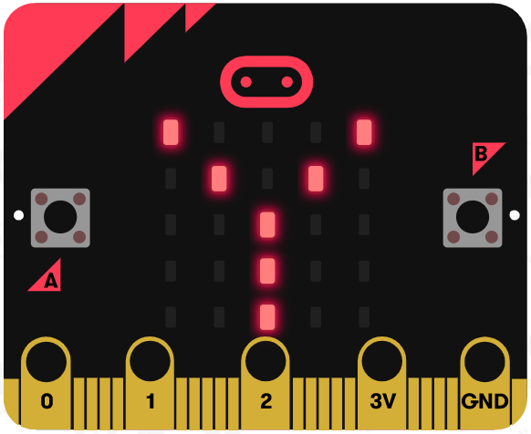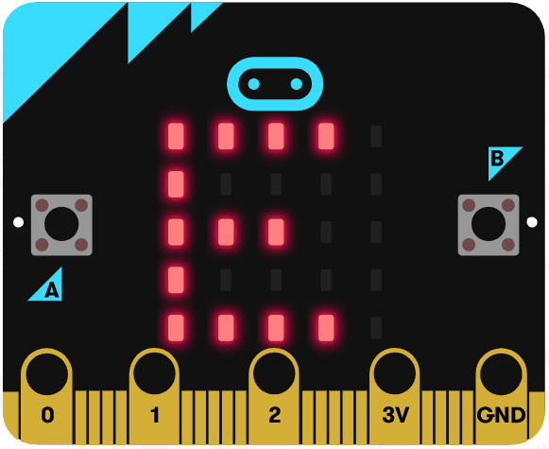

References
Online quick start tutorial: http://microbit.org/guide/quick/
Flowchart tool: https://www.draw.io/
Adapted from the following lesson: https://makecode.microbit.org/lessons/variables

