Activity:
Data Logger – Temperature and Humidity

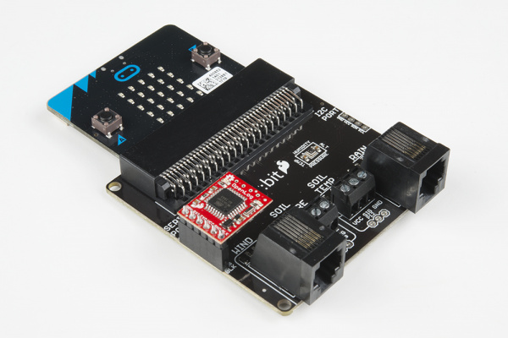

Description:
Build a program that will read the temperature and humidity values and log the values to a CSV file for data analysis. The data logger and Weather:bit will be used to capture the data.

Vocabulary and Concepts:
Temperature Sensor: sensor that reads the current air temperature in Celsius
Humidity Sensor: sensor that reads the current relative humidity

Flowchart:
A flowchart is a way of representing the step-by-step process (algorithm) of your program. For this program, the flowchart is:

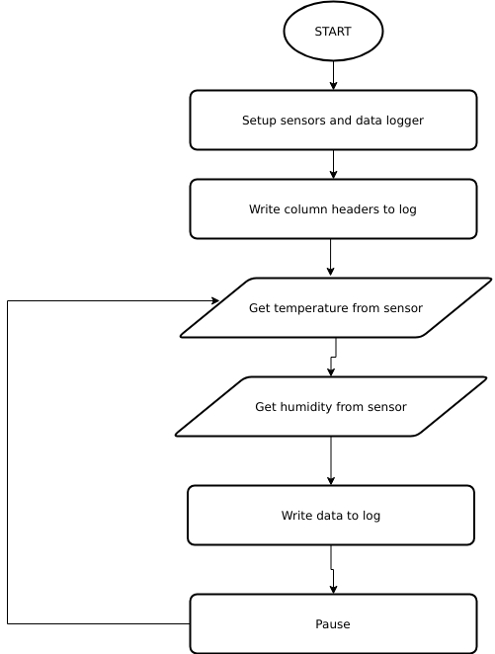

Build the Circuit
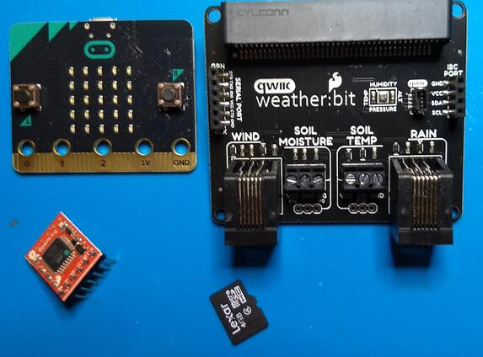
Materials Required:
- Weather:bit board
- Data logger board
- SD card

Hardware Hookup:

Insert the SD card into the data logger board. The printed side of the SD card faces up when you are inserting the card (note – the card will only insert one way). If you are having difficulty inserting the SD card then it may not be oriented correctly. See the pictures below:
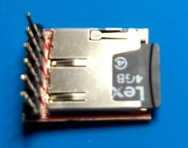
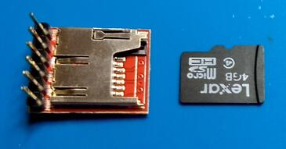

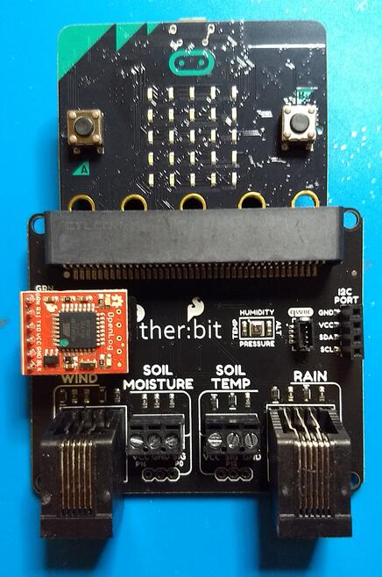
Plug the data logger into the Weather:bit. The gold pins on the data logger board slide into the connector (header) labeled “Serial Port” on the Weather:bit. The logger will only work if it is oriented as shown in the picture to the right.

Finally, insert the micro:bit into the Weather:bit. The buttons on the micro:bit should face up.

Let’s Start Programming!

Step 1: Getting Started
First, we will use the Weather:bit extension for this program. The extension can be used by clicking the “extensions” tab and typing “weather:bit” into the extensions search bar and hitting the <enter> key. Click the Weather:bit extension and the Weatherbit tab should now appear along with the other tabs. Click the Weatherbit tab to grab the “start weather monitoring” block. Click on advanced and scroll down to the serial tab for the serial blocks. Finally, grab all other blocks and build your program.
On Start:
- Initialize the data logger (serial port) and create the column headers

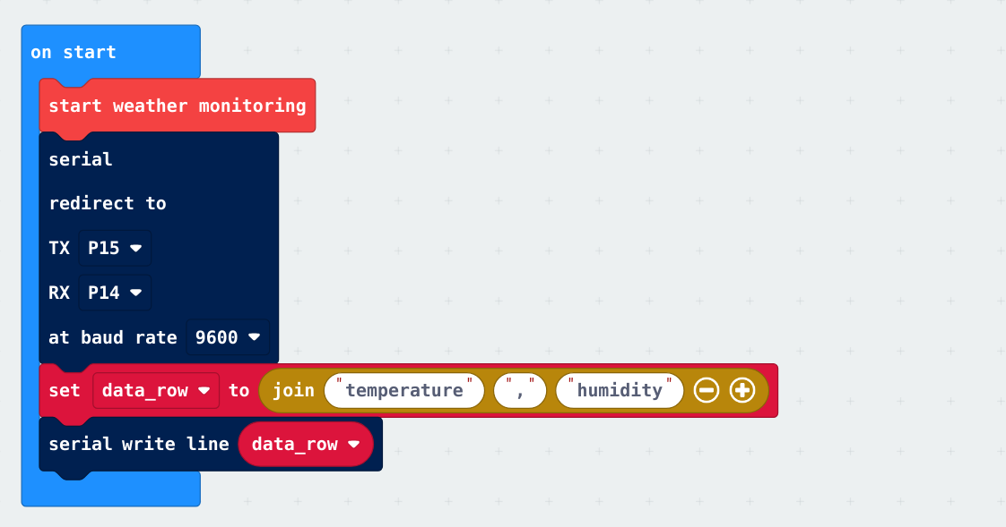
Forever:
- Read the senor values then write them to the CSV file on the SD card
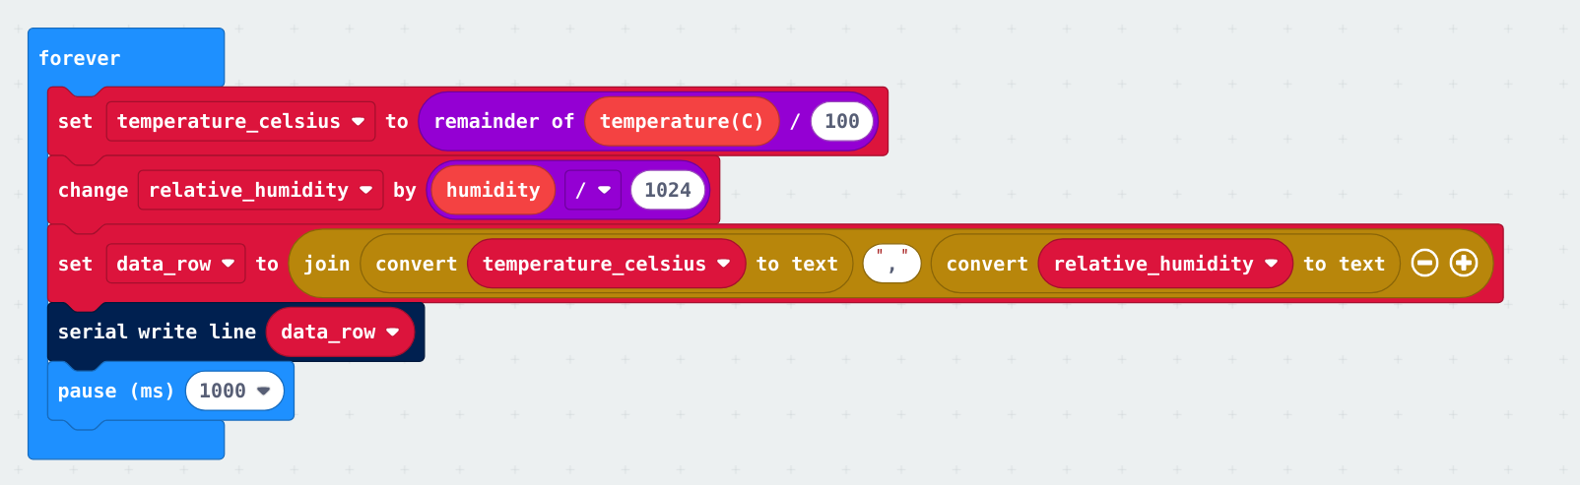

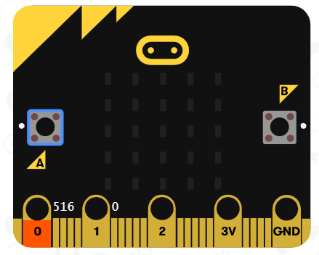
Step 2: Connect to your micro:bit
Step 3: Download the Program
Step 4: Run the Program on the micro:bit
Step 5: After 1 minute, unplug the micro:bit
Step 6: Insert the SD card into a computer
Step 7: Use a spreadsheet program to analyze
the data recorded in the file LOG00001.TXT

Congratulations!
You have created your data logging program!!

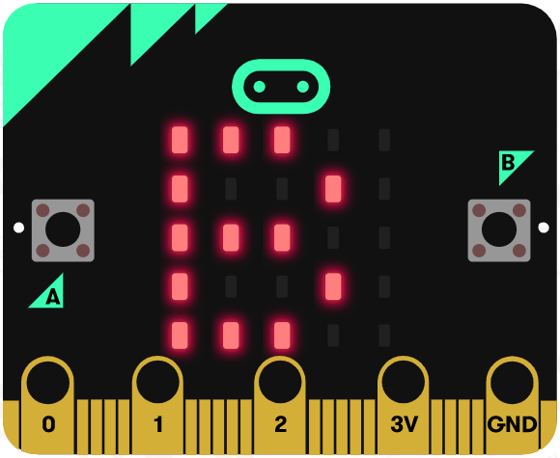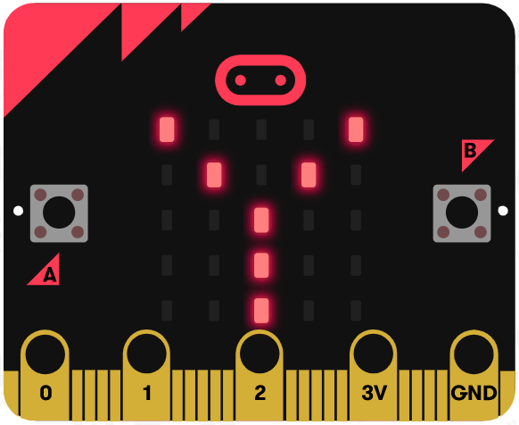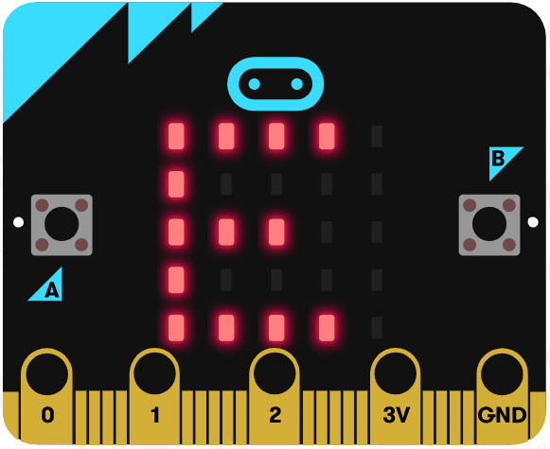

References
Flowchart tool: https://www.draw.io/

