Activity:
Sunlight Sensor

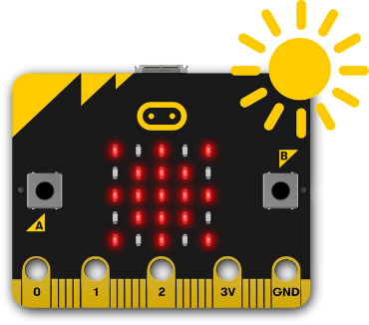

Description:
Build a program that uses a function to read a UV value with the UV sensor and log that value into a csv file.

Vocabulary and Concepts:
UV Sensor: a device that measure ultraviolet light from the sun
Function: A named piece of code that can be called over and over again, sometimes called procedures or methods; a segment of code that includes the steps performed in a specified process.
Initialize: To set something (such as a computer program counter) to a starting position, value, or configuration.

Flowchart:
A flowchart is a way of representing the step-by-step process (algorithm) of you
program. For this program, the flowchart is on the next page

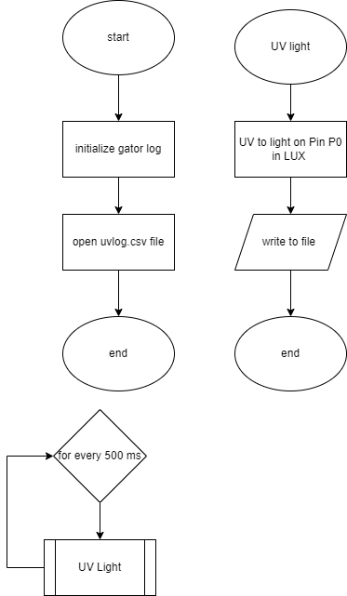

There is always a circle informing you where the algorithm starts. The arrows walk you through to the next steps. The rectangle with two vertical lines on each end denotes a function named “UV Light”. The function is described in the flowchart on the upper right side.

Let’s Start Programming!

Step 1: Getting Started
First, two extensions are needed for this program. The first extension is the gatorlight which can be found by searching gator light in the extension search bar. The next extension is the gator logger and the one we will be using can be found by searching this website, https://github.com/sparkfun/pxt-gator-log, within the extension search bar. Once extensions are found, build the program by dragging the initialize log and open file named into the start block. Name the file, “uvlog.csv”. Next, create the function called UV light and set a variable called UV to get light pin P0. The get light block can be found in the gator light extension. Finally, log the value from the uv sensor by using write line block from gator and grab a convert block from the text tab which is under the advance pull down menu. Place the UV value within the convert block and lastly, call the UV light function.

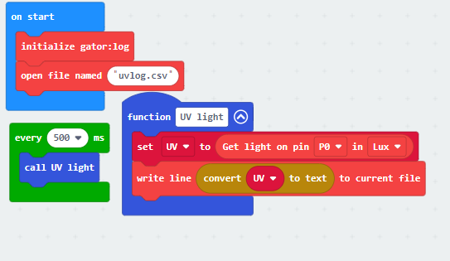

Step 2: Selection Changes

Step 3: Test your Program using the Emulator

Step 4: Download the Program

Step 5: Connect to your micro:bit

Step 6: Running the Program on the micro:bit

Congratulations!
You have created your Sunlight Sensor program!!

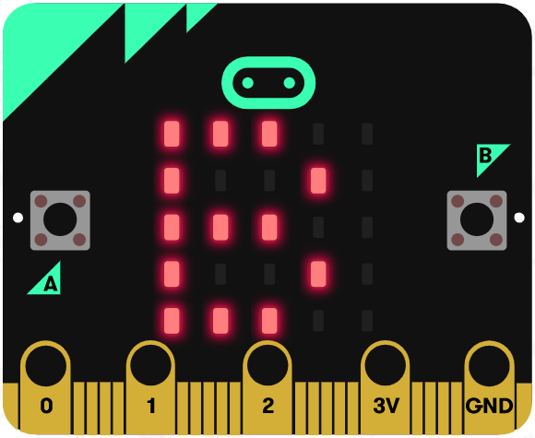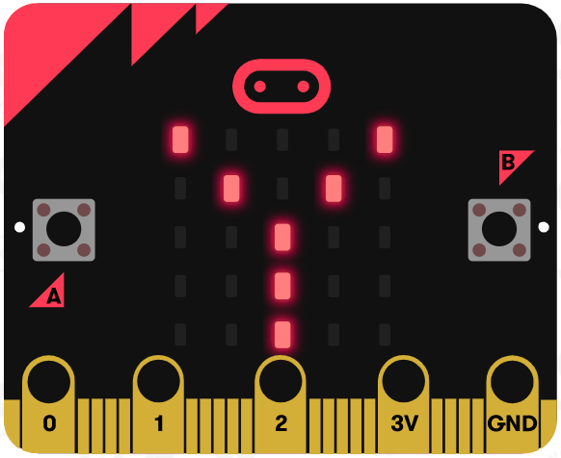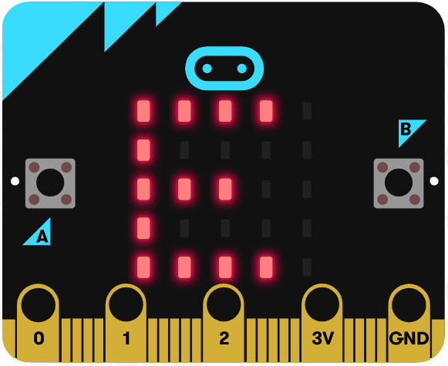

References
Flowchart tool: https://www.draw.io/

