Activity:
Holiday LEDs

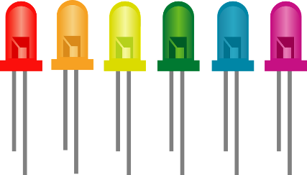

Description:
Build a Holiday light program. This program will consist of three or more LEDs that will blink in a pattern and a potentiometer (control knob) that will control the speed of the blinking lights.

Vocabulary and Concepts:
Potentiometer (control knob): works by turning a shaft which changes the resistance. A potentiometer is a variable resistor.
Variable: An element, feature, or factor that is liable to change; in a programming language, a symbolic representation of some state or property of the program.

Flowchart: A flowchart is a way of representing the step-by-step process (algorithm) of your
program. For this program, the flowchart is shown below in Figure 1.

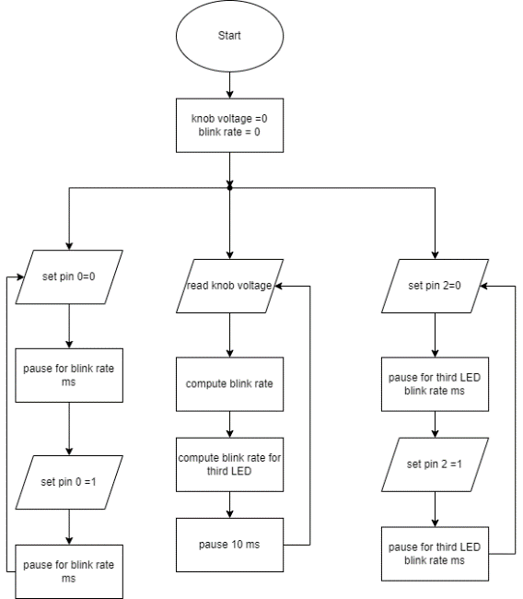
Figure 1.
There is always a circle informing you where the algorithm starts. The arrows walk you through to the next steps. The program should take an input control knob. This knob will control the voltage of Leds while the led should blink by staying in a forever loop.

Build the Circuit:

Materials Required:
- Micro:bit
- USB
- Breadboard
- 1 x 10k potentiometer (control knob)
- 2 x Resistors
- 2 x Jumper wires
- 3 x LEDs
- 5 x Crocodile clip wires

Hardware Hookup:

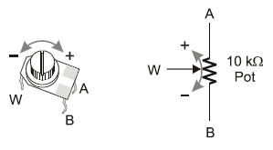
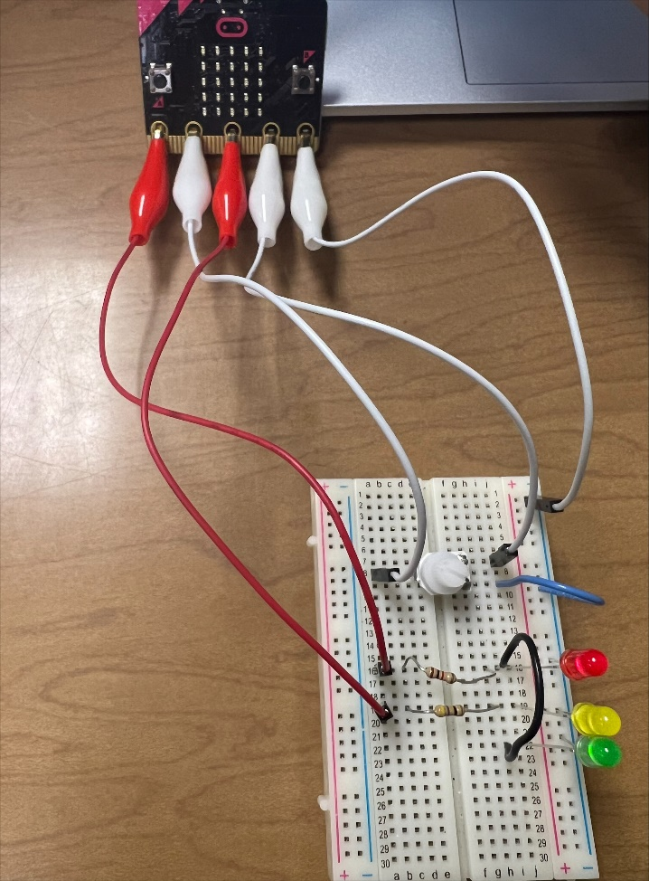
Figure 2. Figure 3.
Instructions:
- Connect the ground (GND) of the micro:bit to the blue minus rail of the breadboard. This will be the ground connection for our LEDs and potentiometer.
- Connect 3 LEDs and resistors to the breadboard. Make sure your shorter lead (cathode) of the LED is in ground. The first LED and resistor is connected to PIN 0. The second LED and resistor is connected to PIN 2. The third LED and resistor is connected to PIN 0 (you can use a jumper wire as shown above in Figure 2).
- Figure 3 illustrates how a potentiometer works and is wired. Place the potentiometer on the breadboard so that no two leads of the potentiometer are connected (in the same row) as shown above in Figure 2. Next, connect PIN 1 to “W”, 3V power to “A”, and GND to “B” on the potentiometer.

Let’s Start Programming!
Step 1: Getting Started
This program consists of three forever loops. Three forever loops are needed to make the program continuously switch the LEDs and activate the knob to read in the voltage. Note that in this program our “forever” loops periodically yield to each other so they can all run (i.e. they aren’t really forever)

First grab the on start block to initiate the variables, “ADC-IN” and “Blink-rate” to 0. Next, set “ADC-IN” variable to read pin 1 and calculate the Blink rate variables by the calculations shown in Figure 4. Finally, grab a forever block and grab the digital write pin 0 to 0 and digital pin 0 to 1. Pause and add the “blink rate variable to the pause block. This allows the led to blink based off the knob. Repeat for another LED, but place the blink rate for the third led variable into the pause block and write to pin 2.

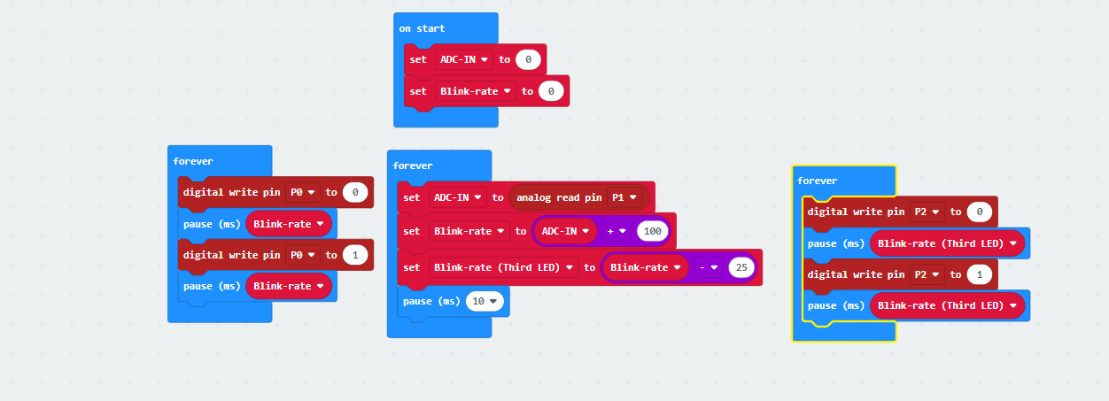
Figure 4.
Step 2: Test your Program using the Emulator
Step 3: Download the Program
Step 4: Connect to your micro:bit
Step 5: Run the Program on the micro:bit

Congratulations!
You have created your Holiday LEDs program!!

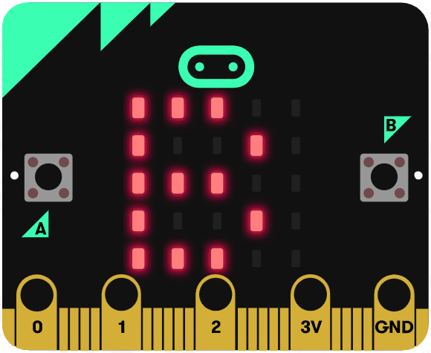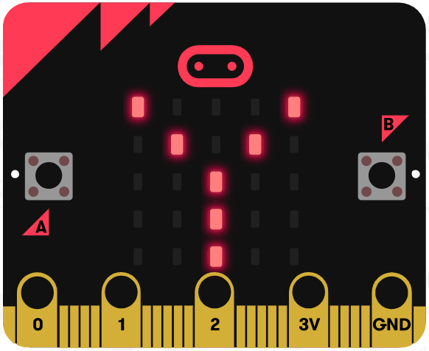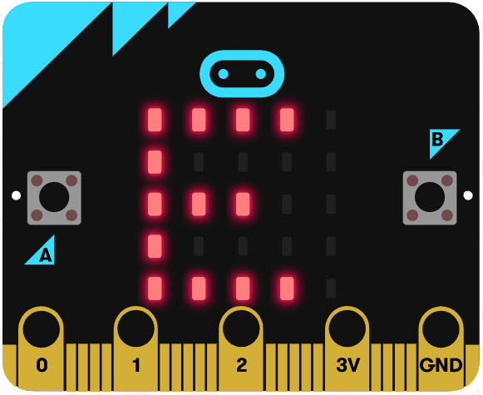

References
Flowchart tool: https://www.draw.io/

