Activity:
LCD Hello World!

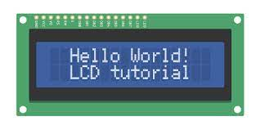
Description:
Build a program that will display hello world blinking onto the LCD screen.
Vocabulary and Concepts:
LCD (Liquid Crystal Display): A type of flat panel display that can let light go through it, or can block the light
Flowchart:
A flowchart is a way of representing the step-by-step process (algorithm) of your program. For this program, the flowchart is:
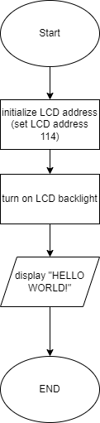

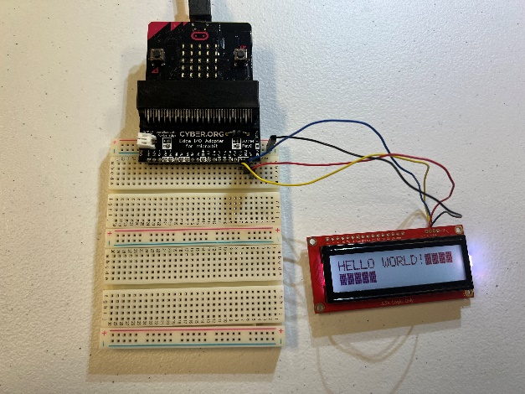
Build the Circuit
Materials Required:
- RGB LCD Screen
- Micro:bit Breakout board (Edge I/O Adapter)
- Breadboard
- Flexible Qwiic cable

Hardware Hookup:

Contact from LCD | Connection to breakout | Connector  (Qwiic Cable)
Connect qwiic cable in the back of LCD | OUT 3.3V (power) | Red wire
Connect qwiic cable in the back of LCD | GND (ground)  _Blue negative column) | Black wire
Connect qwiic cable in the back of LCD | P20 (SDA) | Blue wire
Connect qwiic cable in the back of LCD | P19 (SCL) | Yellow wire

Instructions:
1) Place micro:bit into edge I/O adapter and connect Edge I/O adapter to breadboard with the
positive and negative matching up.
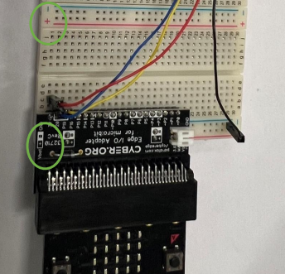

Let’s Start Programming!

Step 1: Getting Started
First, search add the LCD extension. Next, grab on start block from basic tab and grab the needed blocks within the added LCD block from extension
Extensions:
- LCD (type https://evergreen22.github.io/pxt-lcd-rgb-16x2-i2c/ in the extension search bar)

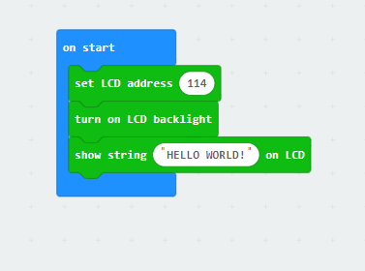

Step 2: Selection Changes
- Change LCD backlight block to the set LCD backlight red, green, blue. This allows to change the color of the screen.
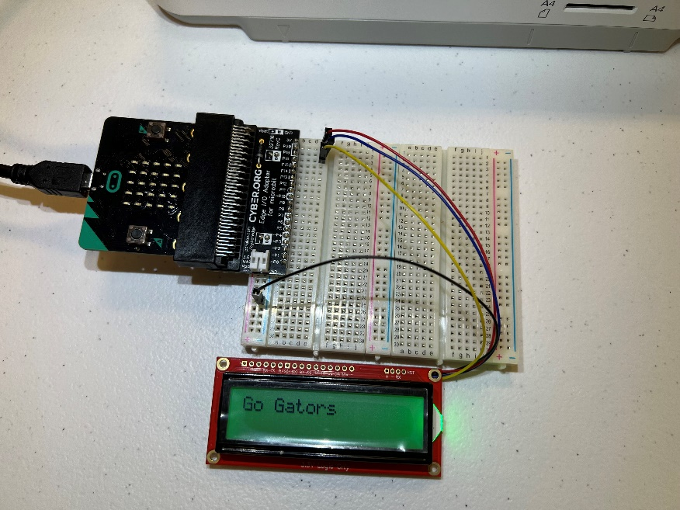
- Change the text in the show string block

Step 3: Download the Program
Step 4: Connect to your micro:bit
Step 5: Running the Program on the micro:bit

Congratulations!
You have created your LCD program!!

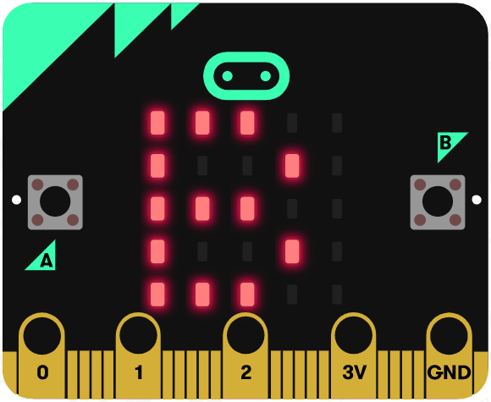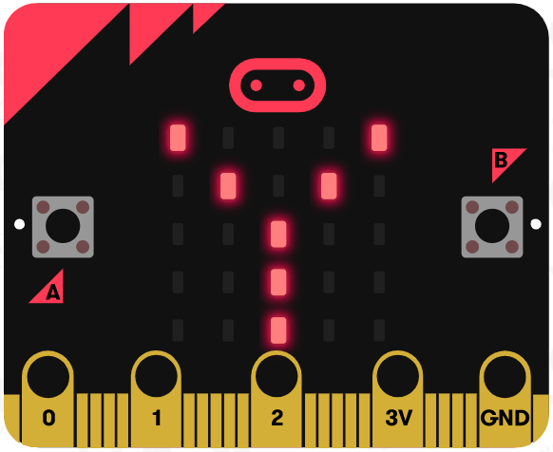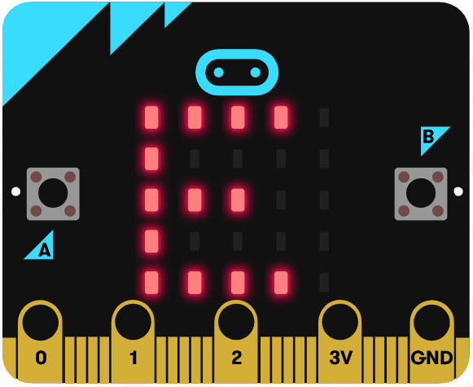

References
LCD Display tutorial: https://www.youtube.com/watch?v=oov5Q48V844
Flowchart tool: https://www.draw.io/

