Activity:
Soil Moisture #4

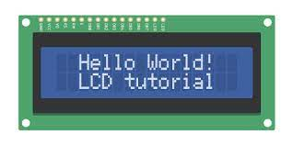

Description:
Build a program that will read the soil moisture value, log the reading to the SD card, and display the value onto the LCD screen using a loop. The soil moisture value will be read with a given soil moisture sensor.

Vocabulary and Concepts:
Soil Moisture Sensor: sensor that estimate volumetric water content
Iteration (Loop): A repetitive action or command typically created with programming loops. Loop action of doing something repeatedly.
LCD (Liquid Crystal Display): A type of flat panel display that can let light go through it, or can block the light

Flowchart:
A flowchart is a way of representing the step-by-step process (algorithm) of your program. For this program, the flowchart is:
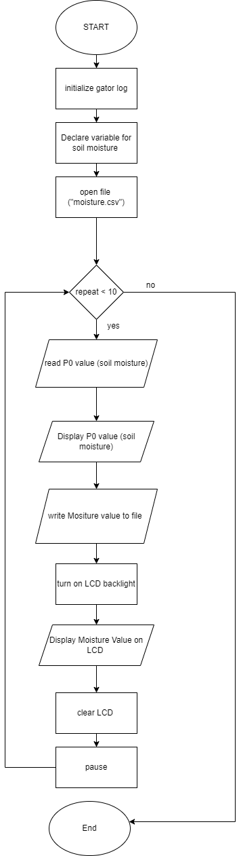
Build the Circuit
Materials Required:
- gator:soil - micro:bit Accessory Board
- gator:log -micro:bit Accessory Board
- gator:bit v2.0 – micro:bit carrier board
- MicroSD card
- MicroSD USB reader
- Twelve Crocodile Clips
- Flexible Qwiic cable
- LCD screen

Hardware Hookup:
Contact from gator:soil | Connection to gator:bit | Connector
PWR (power) | OUT 3.3V | Crocodile Clip
SIG (signal) | P0 | Crocodile Clip
GND (ground) | GND (ground) | Crocodile Clip
Instructions:
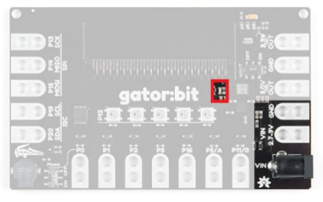
- Turn on power switch located on gator:bit
Contact from gator:log | Connection to gator:bit | Connector
RST | P13 SCK | Crocodile Clip
GND (ground) | GND (ground) | Crocodile Clip
3V3 | OUT 3.3V | Crocodile Clip
RX | P15 MOSI | Crocodile Clip
TX | P14 MISO | Crocodile Clip

- Place SD card in µSD Card Slot
Contact from LCD | Connection to gator:bit | Connector  (Qwiic Cable)
Connect qwiic cable in the back of LCD | OUT 3V (power) | Red wire
Connect qwiic cable in the back of LCD | GND (ground) | Black wire
Connect qwiic cable in the back of LCD | P20 (SDA) | Blue wire
Connect qwiic cable in the back of LCD | P19 (SCL) | Yellow wire
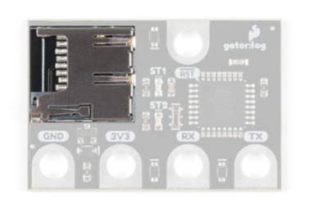

- Place gator:soil sensor in soil
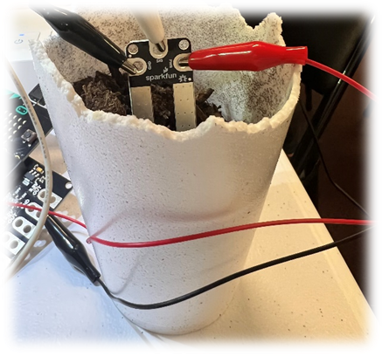

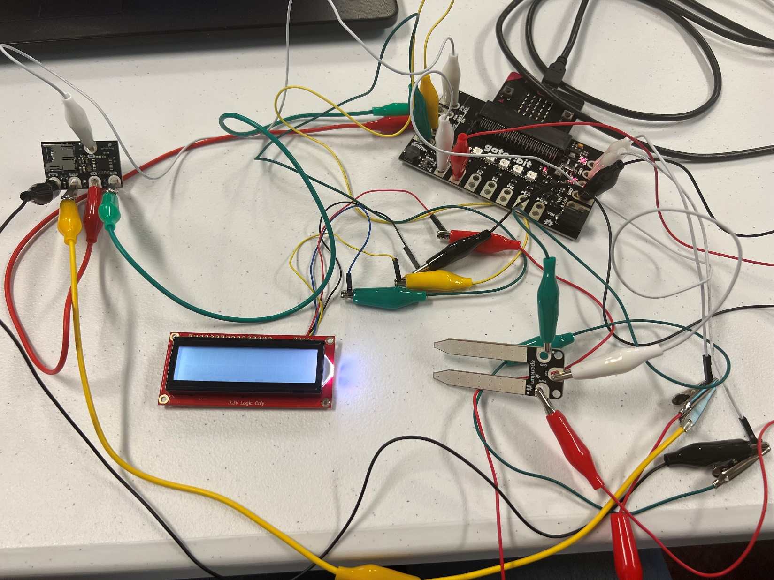

Let’s Start Programming!

Step 1: Getting Started
First, confirm that your last program, Soil_Moisture#3, is working properly. Next, blocks will be added to that program. It will consist of another extension used for the LCD. This extension is received by copying and pasting the following link in the extension search bar, https://github.com/evergreen22/pxt-lcd-rgb-16x2-i2c. The Blocks grabbed from this LCD tab will be turn on backlight, show string and use the convert to text block found in the text tab. Finally, use the LCD cursor block.
Extensions:
- GatorSoil (search “gatorsoil” in extension search bar)
- GatorLog (search https://github.com/sparkfun/pxt-gator-log in the extension search bar)
- LCD (search https://github.com/evergreen22/pxt-lcd-rgb-16x2-i2c in the extension search bar)

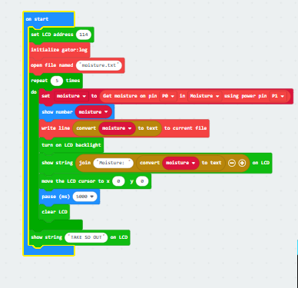

Step 2: Selection Changes
The x and y coordinates can be changed to display on different areas of the LCD 16X2 Screen.
Step 3: Test your Program using the Emulator
Step 4: Download the Program
Step 5: Connect to your micro:bit
Step 6: Running the Program on the micro:bit
Congratulations!
You have created your LCD program!!

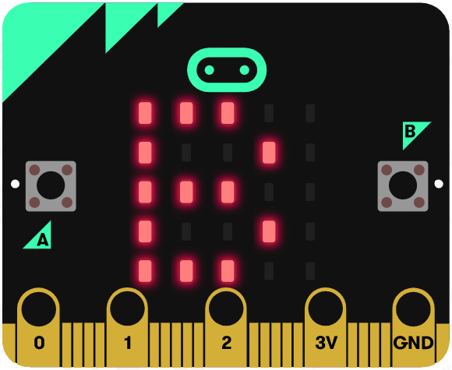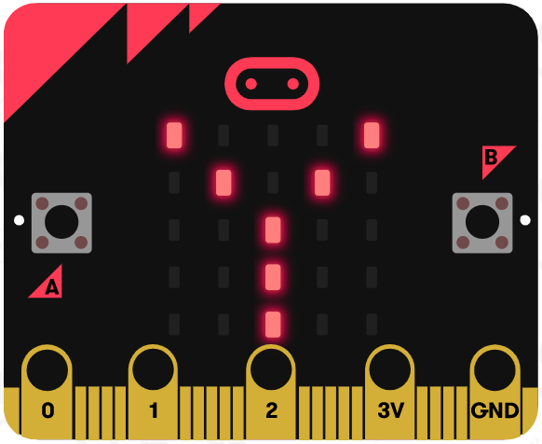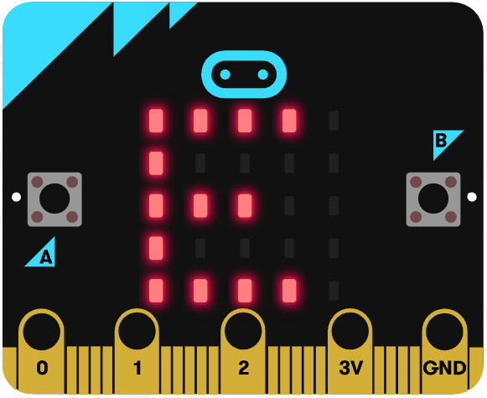

References
LCD Display tutorial: https://www.youtube.com/watch?v=oov5Q48V844
Flowchart tool: https://www.draw.io/

