Activity:
Soil Moisture #3

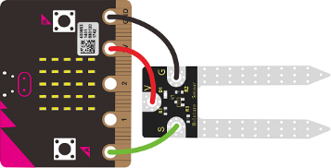

Description:
Build a program that will read the soil moisture value and display the value onto the screen. The reading should be logged to the SD card. The soil moisture value will be read with a given soil moisture sensor and logged with a sparkfun openlog.

Vocabulary and Concepts:
Soil Moisture Sensor: sensor that estimate volumetric water content
Portability: The ability of a user to export data, information, or software entered or created by a software application or computing platform so it may be used in other applications or platforms.

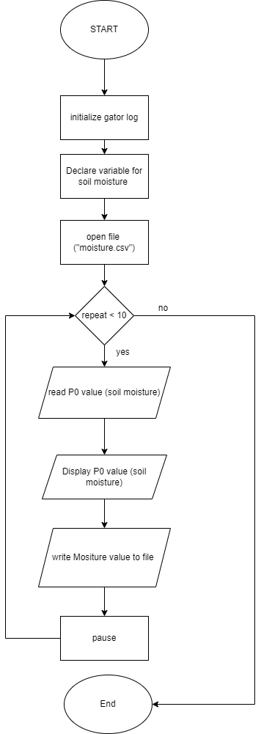
Flowchart:
A flowchart is a way of representing the step-by-step process
(algorithm) of your program. For this program, the flowchart is:

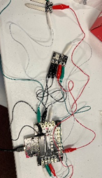
Build the Circuit
  - Materials Required:
- gator:soil - micro:bit Accessory Board
- gator:log -micro:bit Accessory Board
- gator:bit v2.0 – micro:bit carrier board
- MicroSD card
- MicroSD USB reader
- Eight Crocodile Clips

  - Hardware Hookup:
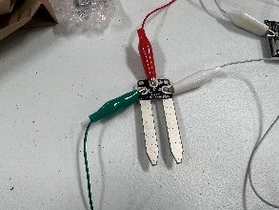  Contact from gator:soil | 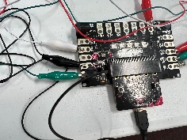  Connection to gator:bit | Connector
PWR (power) | P1 | Crocodile Clip
SIG (signal) | P0 | Crocodile Clip
GND (ground) | GND (ground) | Crocodile Clip
  - Instructions:
- Turn on power switch located on gator:bit
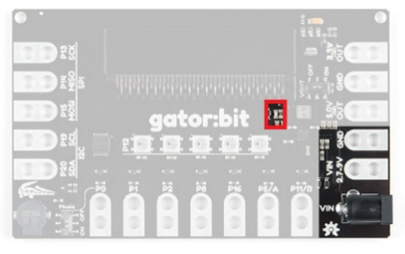

- Place SD card in µSD Card Slot
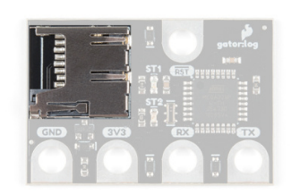
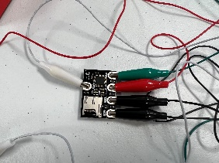  Contact from gator:log | 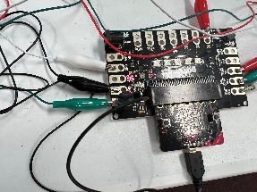  Connection to gator:bit | Connector
RST | P13 SCK | Crocodile Clip
GND (ground) | GND (ground) | Crocodile Clip
3V3 | OUT 3.3V | Crocodile Clip
RX | P15 MOSI | Crocodile Clip
TX | P14 MISO | Crocodile Clip

/

Let’s Start Programming!

Step 3: Getting Started
First, grab blocks from previous program Soil_Moisture2 such as the extensions called “Gator soil”. However, this program consists of another extension called gator log and can be found by copying and pasting the following site into the extension search bar: https://github.com/sparkfun/pxt-gator-log
The new blocks from the gator log tab will be initialize gator log and open file named to open the file. Name the file “moisture.txt” and to write to this file will consist of the write line to current file block. Lastly, grab the convert to text from the text tab and place it into the write line block. This will allow to write the moisture value as text in the moisture.txt file.
Extensions:
- GatorSoil (search “gatorsoil” in extension search bar)
- GatorLog (search https://github.com/sparkfun/pxt-gator-log in the extension search bar)

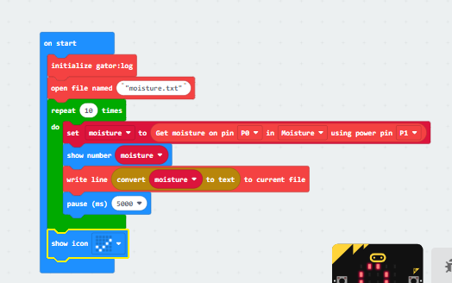
Step 4: Selection Changes
Try different loops:
Grab a loop of your choice from the loop box experiment according to the following
- WHILE LOOP: place a conditional within this loop to test such as while true or while false.
- FOR LOOP: insert 9 which is iterating through the code 0-9 times which is 10 times
- EVERY LOOP: loop every time stamp such as insert a minute, then it will loop through code every minute

Step 5: Test your Program using the Emulator
Click the play button on the emulator. Next, slide up and down on pin 0 on the emulator to change different values. Finally, click show data simulator and the different values should be shown in the text file.
Step 7: Connect to your micro:bit
Step 8: Download the Program
Step 9: Running the Program on the micro:bit
- Once downloaded, take out the SD card out the µSD Card Slot
- Place the SD card into the USB reader
- Insert USB reader into computer and view data file.

Congratulations!
You have created your Data Logger program!!

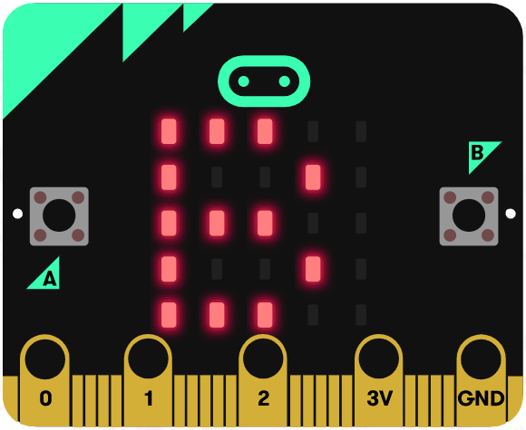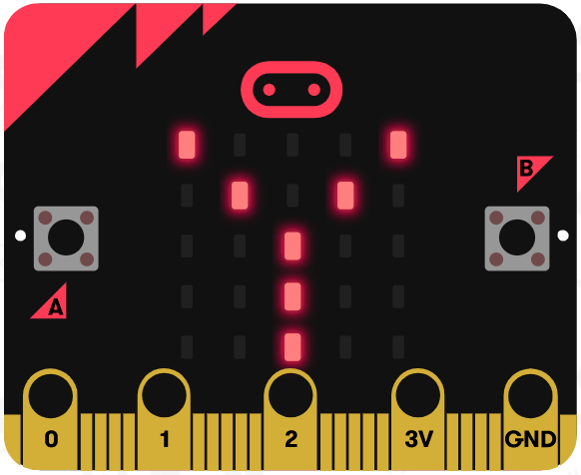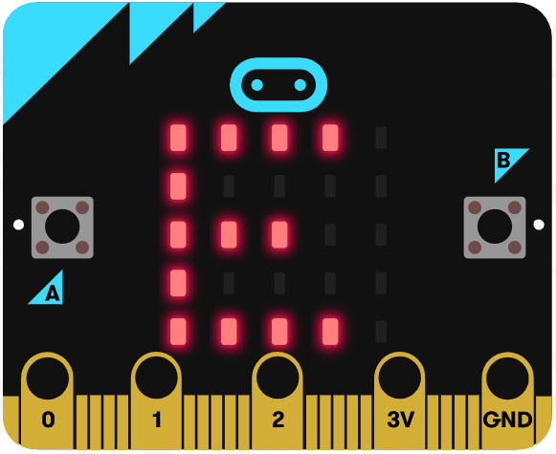

References
Online Moisture Sensor tutorial: https://youtu.be/S8NppVT_paw
SparkFun gator:log Hookup Guide: https://learn.sparkfun.com/tutorials/sparkfun-gatorlog-hookup-guide/hardware-overview
Flowchart tool: https://www.draw.io/

