Activity:
Soil Moisture #2

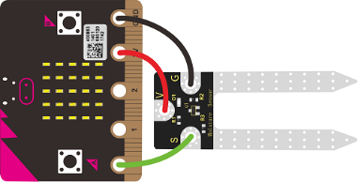

Description:
Build a program that will read the soil moisture value and display the value onto the screen using a loop. The soil moisture value will be read with a given soil moisture sensor.

Vocabulary and Concepts:
Soil Moisture Sensor: sensor that estimate volumetric water content
Iteration (Loop): A repetitive action or command typically created with programming loops. Loop action of doing something repeatedly.

Flowchart:
A flowchart is a way of representing the step-by-step process (algorithm) of your program. For this program, the flowchart is:
This program contains a while loop that is always true meaning the program will never end. In that case, the flow chart will not consist of an end circle.

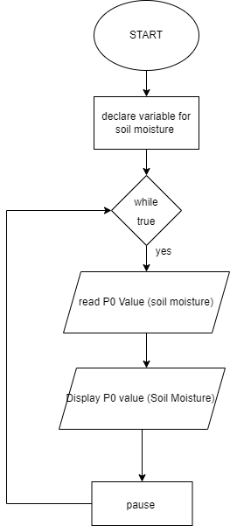

Build the Circuit
Materials Required:
- gator:soil - micro:bit Accessory Board
- gator:bit v2.0 – micro:bit carrier board
- Three Crocodile Clips

Contact from gator:soil | Connection to gator:bit v2.0 | Connector
PWR (power) | P1 | Crocodile Clip
SIG (signal) | P0 | Crocodile Clip
GND (ground) | GND (ground) | Crocodile Clip
Hardware Hookup:
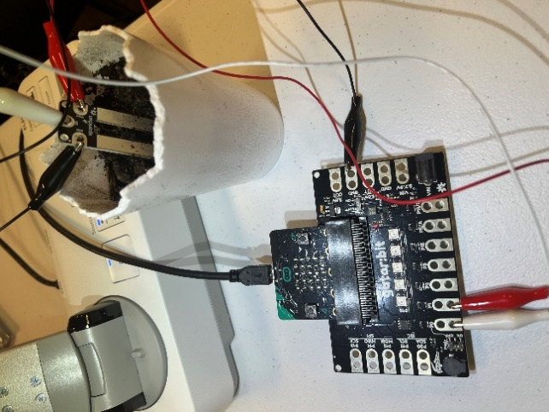
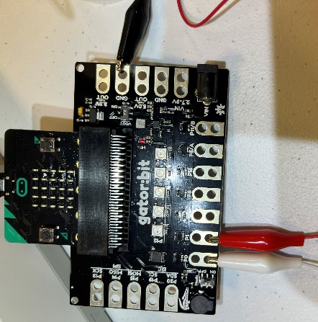

Instructions:
- Place gator:soil sensor in soil
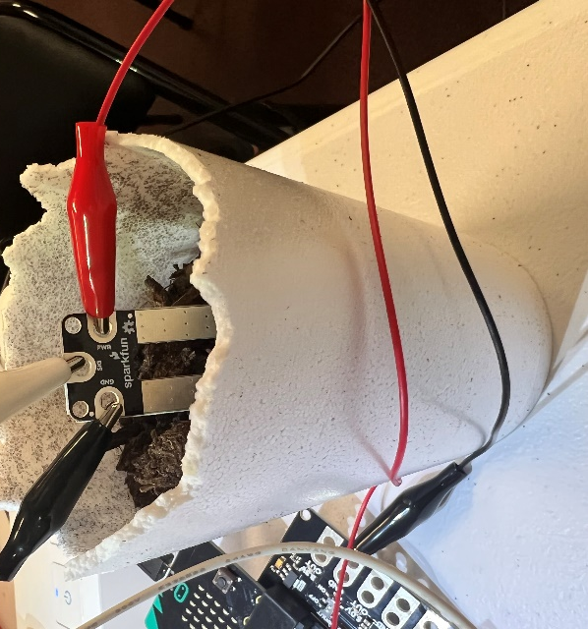

Let’s Start Programming!

Step 1: Getting Started
This program will consist of the same process with the Soil_Moisture1 program. First, we will use the Gator Soil extension for this program. The extension can be used by clicking the “extensions” tab and typing “Gator Soil” into the extensions search bar. Next, the gator soil extension should pop up. Click the extension and the gator soil tab should now appear along with the other tabs. Click the gator soil tab to grab the get moisture block. Set pin P0 in moisture using power pin P1. Finally, the difference is this program is that a loop is used in this program. The loop that will be used is the while true loop which can be found in the loops tab and place all other blocks.
Extensions:
- GatorSoil

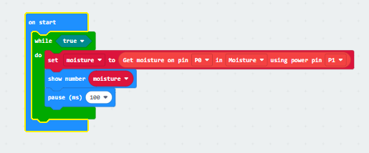

Step 2: Selection Changes
Changes may consist of changing to any pin number, but P0 and P1 are good choices for now.
The ADCValue may also be changed to moisture. The ADC value is the moisture value divided by 100.

Step 3: Test your Program using the Emulator
Since it is a loop, test your program by pressing start on the emulator and changing the value of the pin 0 by clicking on pin 0 on the microbit and dragging up and down along the pin.
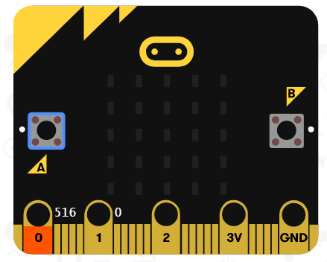

Step 4: Connect to your micro:bit
Step 5: Download the Program
Step 6: Running the Program on the micro:bit
Congratulations!
You have created your Soil Sensor program!!
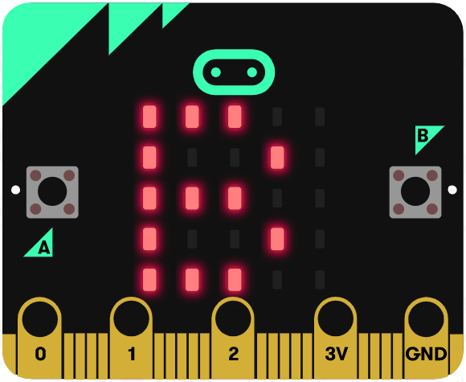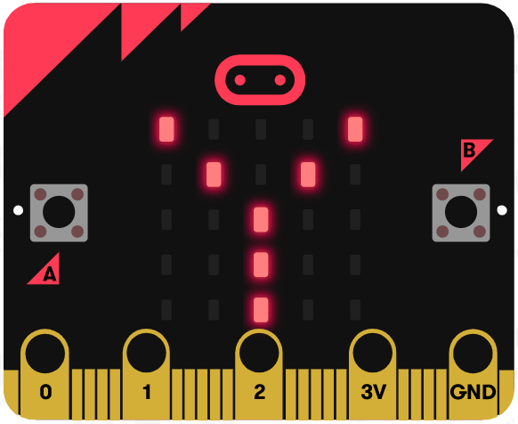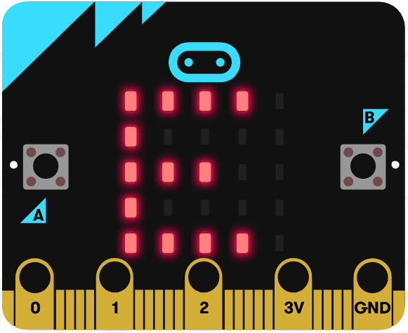
References
Online Moisture Sensor tutorial: https://youtu.be/S8NppVT_paw
SparkFun gator:soil Hookup Guide: https://learn.sparkfun.com/tutorials/sparkfun-gatorsoil-hookup-guide?_ga=2.146091443.620133083.1655840734-1398352755.1654058977
Flowchart tool: https://www.draw.io/

