Activity:
Temperature Indicator #2 (Thermometer)

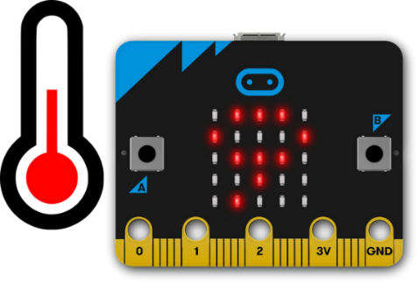

Description:
Build a program that will convert the temperature from Celsius to Fahrenheit, therefore the temperature will be displayed in Fahrenheit once button A is pressed on the microcontroller. The temperature is read using a built-in temperature sensor.

Vocabulary and Concepts:
Variable: An element, feature, or factor that is liable to change; in a programming language, a symbolic representation of some state or property of the program.
Sensor: An input device that reads or measures a physical property and converts it to a numerical value.
Temperature Sensor: a sensor that measures the temperature in degrees Celsius (scientific units)
Flowchart: A flowchart is a way of representing the step-by-step process (algorithm) of you
program. For this program, the flowchart is
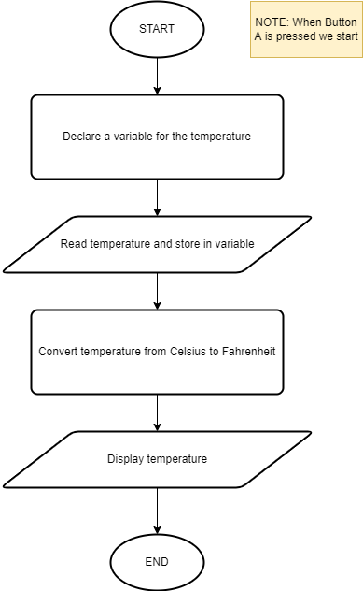

There is always a circle informing you where the algorithm starts. The arrows walk you through to the next steps. The program should take an input pressed button. Next, output the temperature. Finally, the program should end.

Let’s Start Programming!

Step 1: Accessing the Project Editor Page
You must be connected to the Internet and you may use any modern browser such as Edge, Firefox, Chrome, or Safari.

Start the micro:bit coding tool by using a web browser to connect to microbit.org/code. Once the webpage is loaded, scroll down to see the MakeCode Editor Section. Click the “Let’s Code” button. This will take us to a new page where you will click the “+ New Project” box. It will take a moment to load and start.

The coding tool we are using is called the Javascript Blocks Editor. Here is what it looks like when it is ready:
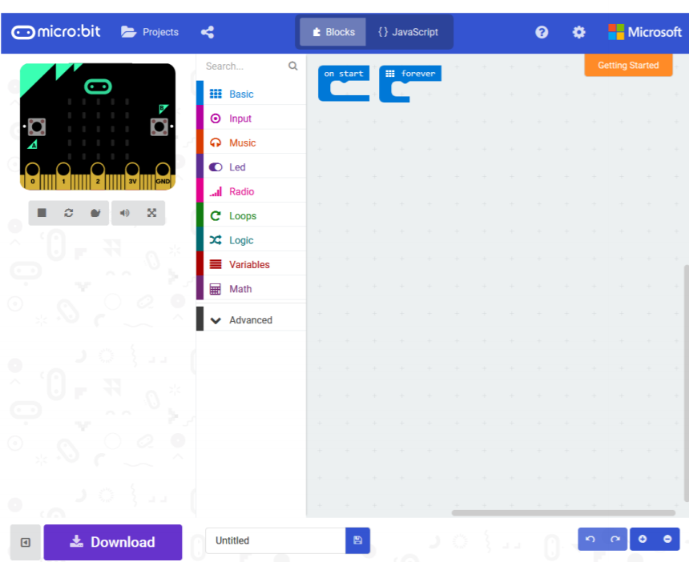

Step 2: Features of the Editing Tool
In the upper left hand corner is the micro:bit emulator. You can test your program here before you download it to the micro:bit. In the middle of the screen is the blocks chooser. The blocks are grouped into categories like Basic, Input, and Variables. The right side of the screen is where you will create your program by arranging blocks. Notice that two blocks are automatically inserted. The “on start” block contains any code that needs to happen one time only when the micro:bit is turned on. The “forever” block contains the remainder of your program. Other controls in the editor are for downloading your program, switching between blocks and Javascript, help, settings, and saving your projects. Let’s code!
Step 3: Getting Started
Click on “Input” and drag the “on button pressed” block onto the editor window. Next, create a variable by going to the “variables” tab and dragging the “set” block under the “on button pressed” block. On the “set” block, click the drop-down button and click “new variable”. Once clicked, type a variable name such as “temperature”. The temperature variable should be set to the temperature ( C ) block which is found within the input tab. Next, temperature needs to be converted to Fahrenheit. It is converted by using the following formula, Fahrenheit = (Celsius * 1.8) + 32. Therefore, another “set” block is needed from the variables tab using the temperature variable. In order to use to formula by grabbing an addition and multiplication block from the math tab. Now, grab the created temperature variable from the variables tab and place into the multiplication block and multiply by 1.8. Then, add the multiplication tab and 32 by placing the multiplication tab into the first spot of the addition block and typing 32 into the second spot. Now, place that created formula into the second set block. Finally, go into the basic tab and grab the show number tab, place it under the second set block and place the temperature variable into the slot. An example is shown below in the visual.
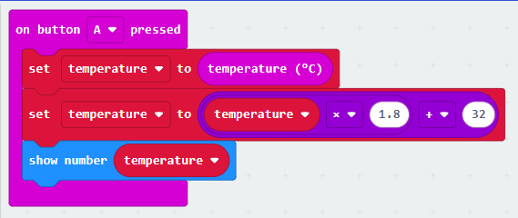

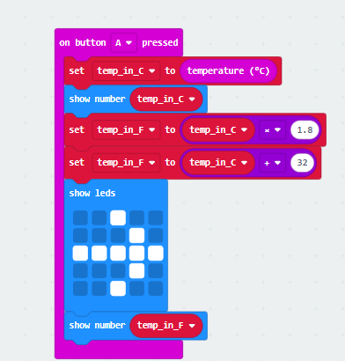
Step 4: Selection Changes
Certain changes can be made within the “on button pressed” block by choosing between A, B, or A+B which means we can determine if we would like to change the temperature when button A is pressed on the microbit, button B, or Both buttons with A+B.
Step 5: Test your Program using the Emulator
Once you have completed assembling your blocks, then press the button A on the emulator. If your program is working correctly, then it is time to download it to the micro:bit. Before we download it, let’s give our program a name. Click on the word “Untitled” in the textbook on the bottom left side of the editor.
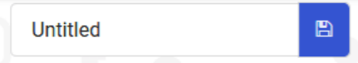
Name your program “Temperature Indicator #2”. You do NOT need to click the disk icon to change the name—pressing the disk icon will save your program by downloading it to your computer.

Step 6: Download the Program
Now we need to download the completed program. Click the “Download” button and save the program on your computer. Be sure to note where you have saved the program.

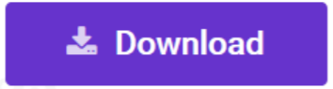
Step 7: Connect to your micro:bit
Next, connect your micro:bit to your computer with the USB cable. The following is where the USB cable needs to attach to the micro:bit.

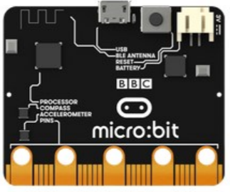

Step 8: Running the Program on the micro:bit
If you are using Windows, click the Start icon at the bottom left of your screen. Open the File Explorer (you can search for File Explorer if not displayed on your Start menu) and find your downloaded program. Right click on the program and select “Send To”. Then select “Microbit”. If you are using a Mac, drag and drop the program onto the MICROBIT device from the Finder. This will install your program on the micro:bit. The yellow LED on the back of the micro:bit will blink while your program is being installed. Your program will run once the selected button is pressed.

Congratulations!
You have created your Thermometer program!!

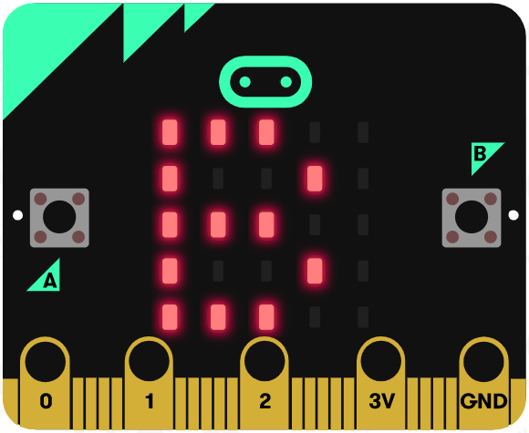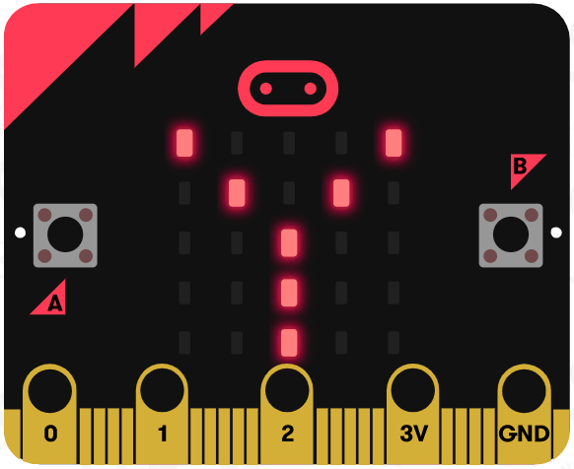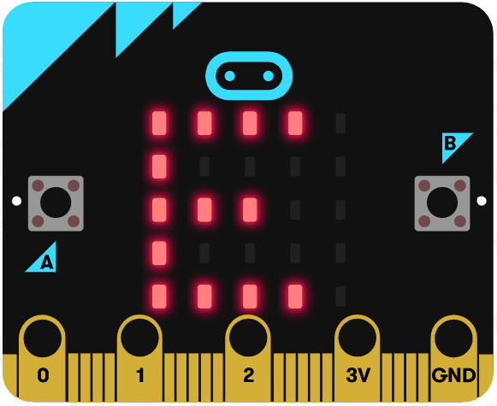

References
Online Thermometer tutorial: https://microbit.org/projects/make-it-code-it/thermometer/
Flowchart tool: https://www.draw.io/

