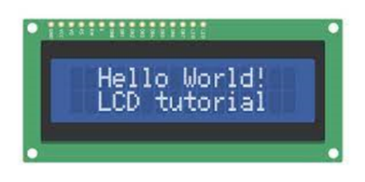
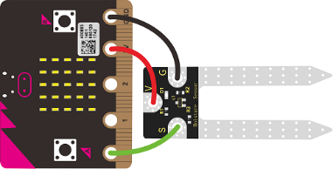
Activity:
Soil Sensor Function

Description:
Build a program that will have a function read the soil moisture value, log the reading to the SD card, and display the value onto the LCD screen using a loop. The soil moisture value will be read with a given soil moisture sensor.

Vocabulary and Concepts:
Soil Moisture Sensor: sensor that estimate volumetric water content
Iteration (Loop): A repetitive action or command typically created with programming loops. Loop action of doing something repeatedly.
LCD (Liquid Crystal Display): A type of flat panel display that can let light go through it or can block the light.
Function: A named piece of code that can be called as many times as possible, sometimes called procedures or method; a segment f code that includes the steps performed in a specified process.

Flowchart:
A flowchart is a way of representing the step-by-step process (algorithm) of your program. For this program, the flowchart is:

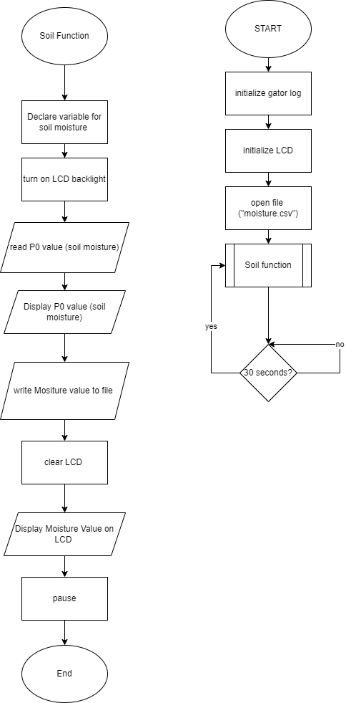
Build the Circuit
  - Materials Required:
- gator:soil - micro:bit Accessory Board
- gator:log -micro:bit Accessory Board
- gator:bit v2.0 – micro:bit carrier board
- MicroSD card
- MicroSD USB reader
- Twelve Crocodile Clips
- Flexible Qwiic cable
- LCD screen
- Dry and wet soil

  - Hardware Hookup:
Contact from gator:soil | Connection to gator:bit | Connector
PWR (power) | OUT 3.3V | Crocodile Clip
SIG (signal) | P0 | Crocodile Clip
GND (ground) | GND (ground) | Crocodile Clip
  - Instructions:
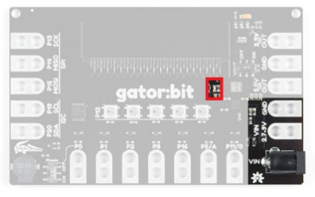
- Turn on power switch located on gator:bit
Contact from gator:log | Connection to gator:bit | Connector
RST | P13 SCK | Crocodile Clip
GND (ground) | GND (ground) | Crocodile Clip
3V3 | OUT 3.3V | Crocodile Clip
RX | P15 MOSI | Crocodile Clip
TX | P14 MISO | Crocodile Clip

- Place SD card in µSD Card Slot
Contact from LCD | Connection to gator:bit | Connector  (Qwiic Cable)
Connect qwiic cable in the back of LCD | OUT 3V (power) | Red wire
Connect qwiic cable in the back of LCD | GND (ground) | Black wire
Connect qwiic cable in the back of LCD | P20 (SDA) | Blue wire
Connect qwiic cable in the back of LCD | P19 (SCL) | Yellow wire
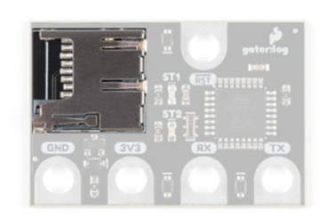

- Place gator:soil sensor in soil
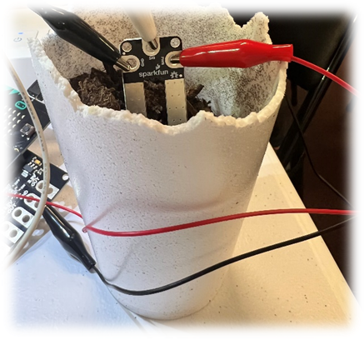

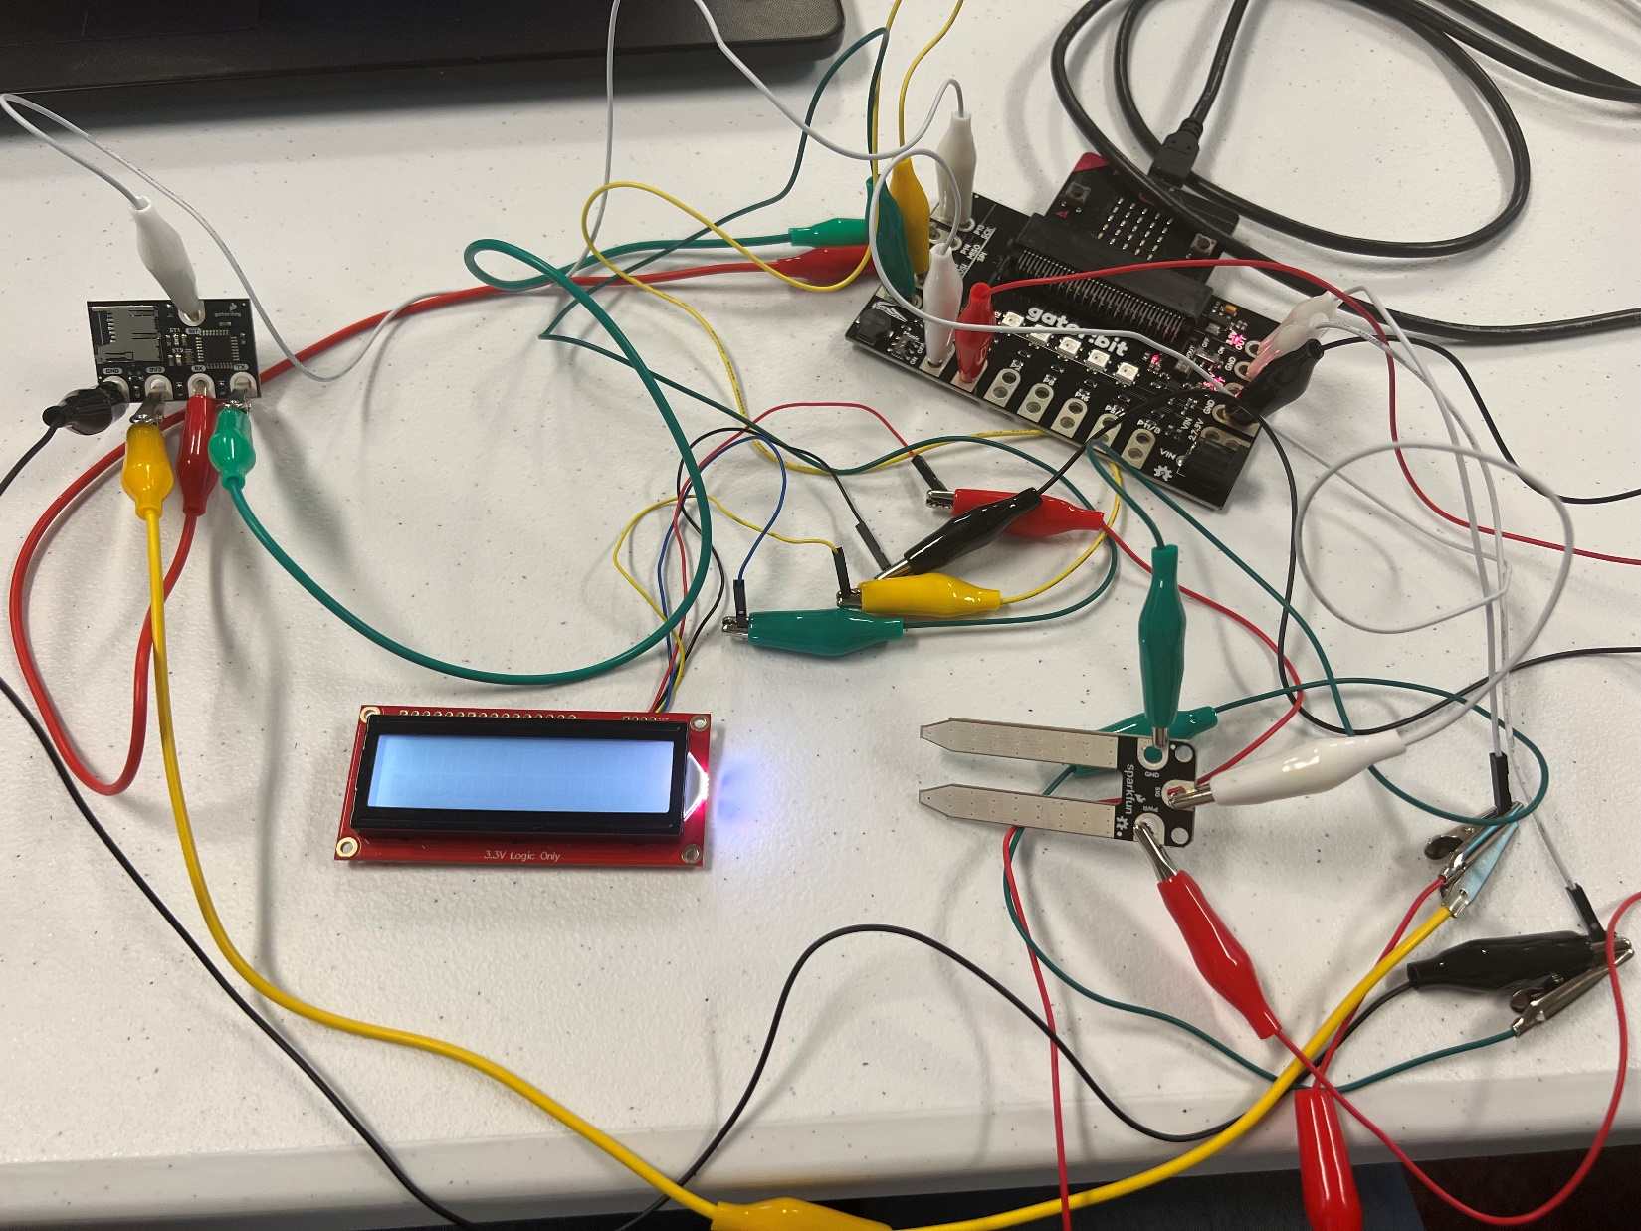

Let’s Start Programming!

Step 1: Getting Started
First, copy the code from the LCD display (soil moisture) program. Next, go to functions tab and select make a function. Call the function, “soil function”. Once created, it should create a block to grab. Grab the function block and place the remaining code within the block. Finally, grab an on start block and place a call soil function within the on start block.
Extensions:
- GatorSoil (search “gatorsoil” in extension search bar)
- GatorLog (search https://github.com/sparkfun/pxt-gator-log in the extension search bar)
- LCD (search https://github.com/evergreen22/pxt-lcd-rgb-16x2-i2c in the extension search bar)
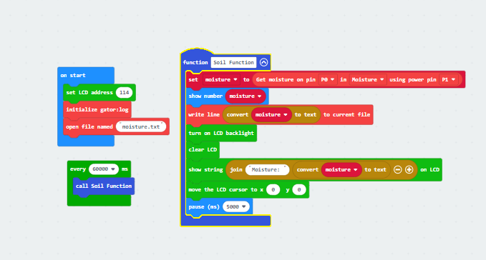

Step 2: Selection Changes
Step 3: Test your Program using the Emulator
Step 4: Connect to your micro:bit
Step 5: Download the Program
Step 6: Running the Program on the micro:bit
Congratulations!
You have created your Soil Moisture Function program!!
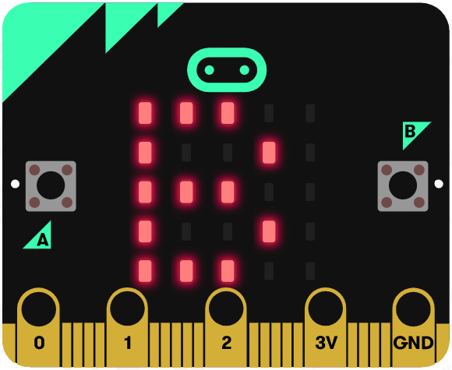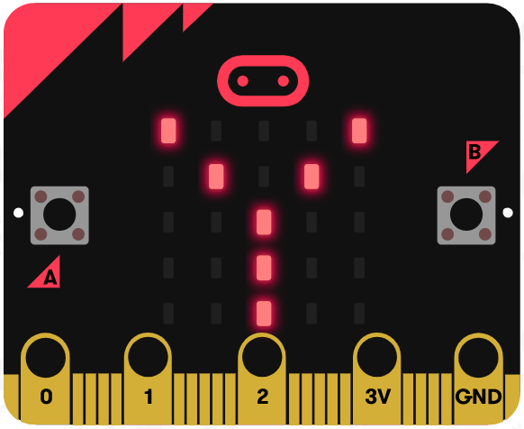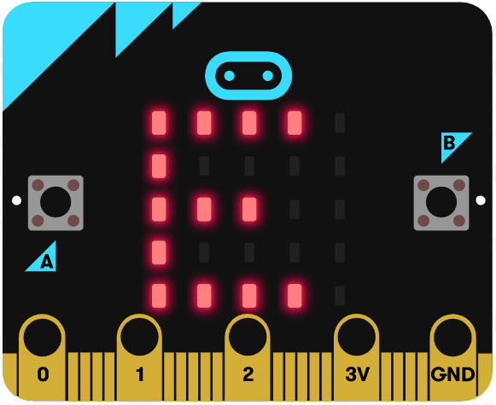

References
LCD Display tutorial: https://www.youtube.com/watch?v=oov5Q48V844
Flowchart tool: https://www.draw.io/

