Activity:
LED Function

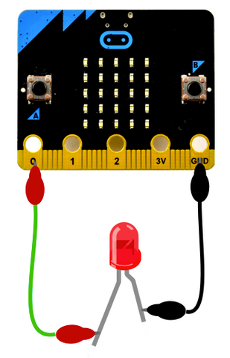

Description:
Create a program that will have two functions. One function should turn the LED on and the other function should turn the LED off.

Vocabulary and Concepts:
Variable: An element, feature, or factor that is liable to change; in a programming language, a symbolic representation of some state or property of the program.
Sensor: An input device that reads or measures a physical property and converts it to a numerical value.
Temperature Sensor: a sensor that measures the temperature in degrees Celsius (scientific units)
Function: A named piece of code that can be called repeatedly, sometimes called procedures or methods: a segment of code that includes the steps performed in a specified process.

Flowchart:
A flowchart is a way of representing the step-by-step process (algorithm) of you
program. For this program, the flowchart is
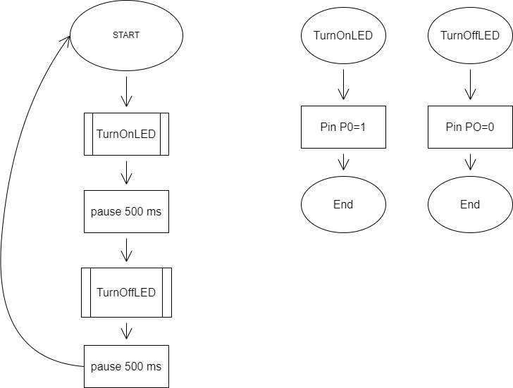

There is always a circle informing you where the algorithm starts. The arrows walk you through to the next steps. The rectangle represents action which is used for pausing and setting the pins. To call a function, the rectangle with the lines is used. As always, the end is used to end the program or in this case, is used to end the function. The program does not end because the code uses a forever block.

Build the Circuit:
  - Materials Required:
- Micro:bit
- Two Crocodile clip pins
- One LED light
- One resistor
- One Pin wire

  - Hardware Hookup:

Contact from  Micro:bit | Connection to Breadboard | Connector
P0 | Check instruction 1 (ex: h4) | Crocodile pin wire
GND | GND (ex: negative blue column) | Crocodile pin wire

  - Instructions:
- Can be placed anywhere on breadboard from column a-e and row 1-30 or use example in chart.
- Resistor: one end of resistor can be anywhere(ex:h13) and the other end must be on the same row of the LED(ex: row 6)
- LED: The longer leg(anode) of LED must be on the same row as the pin wire (ex: row 4)and the shorter leg(cathode) of LED must be the same row as the resistor(ex: row 6)
- Pin wire: connect the pin wire on the same row as the resistor (ex: row 13) and the other end to GND(blue negative column)

Let’s Start Programming!

Step 1: Getting Started
This program consists of functions. Therefore, go to functions drawer and create two functions. The first function should be called, “TurnOnLED”. Next, grab the digital write pin block from the pins drawer under the advanced tab. Place the pin block into the “TurnOnLED” function. Next, make sure P0 is selected and write pin PO to 1. Second, do the same thing with other function, but name it “TurnOffLED” and have PO to 0. Finally, call the functions by grabbing the call functions from the function tab and the pause blocks from the basic drawer. Place all blocks in a forever block. An example is given below.

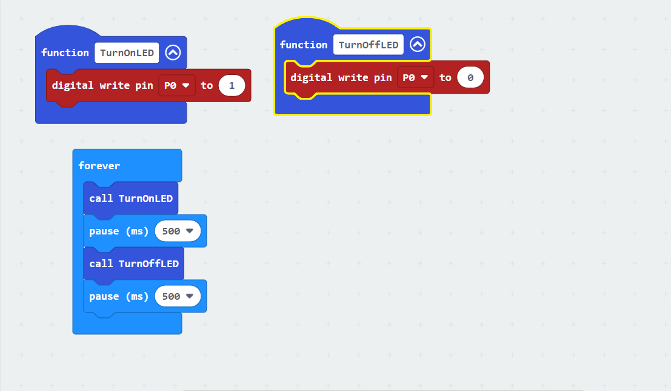

Step 2: Selection Changes
The pause can be changed which change the pace of how the LED blinks.
Step 3: Test your Program using the Emulator
Step 4: Download the Program
Step 5: Connect to your micro:bit
Step 6: Running the Program on the micro:bit

Congratulations!
You have created your Function program!!

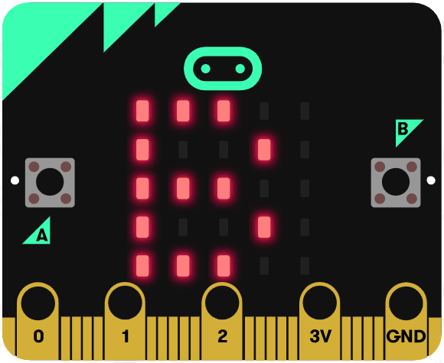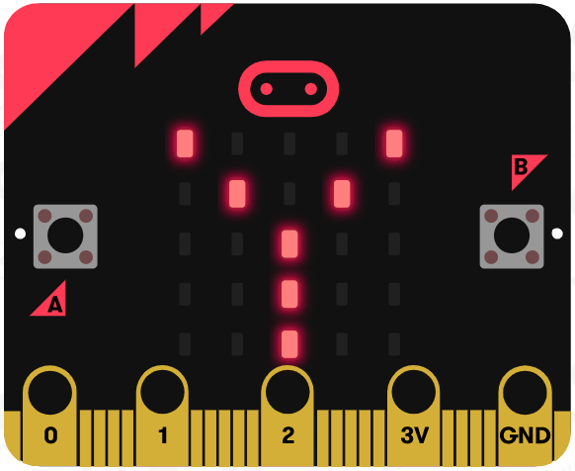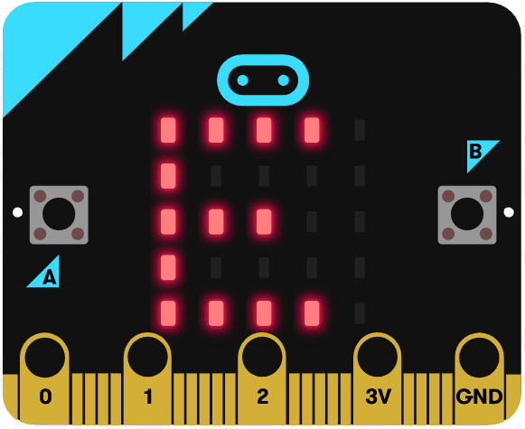

References
Flowchart tool: https://www.draw.io/

