Activity:
Fan Function

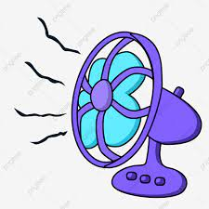
Description:
Modify the temperature fan controller program by converting it to a function.
Vocabulary and Concepts:
Variable: An element, feature, or factor that is liable to change; in a programming language, a symbolic representation of some state or property of the program.
Sensor: An input device that reads or measures a physical property and converts it to a numerical value.
Temperature Sensor: a sensor that measures the temperature in degrees Celsius (scientific units)
Function: A named piece of code that can be called repeatedly, sometimes called procedures or methods: a segment of code that includes the steps performed in a specified process.

Flowchart:
A flowchart is a way of representing the step-by-step process (algorithm) of you
program. For this program, the flowchart is
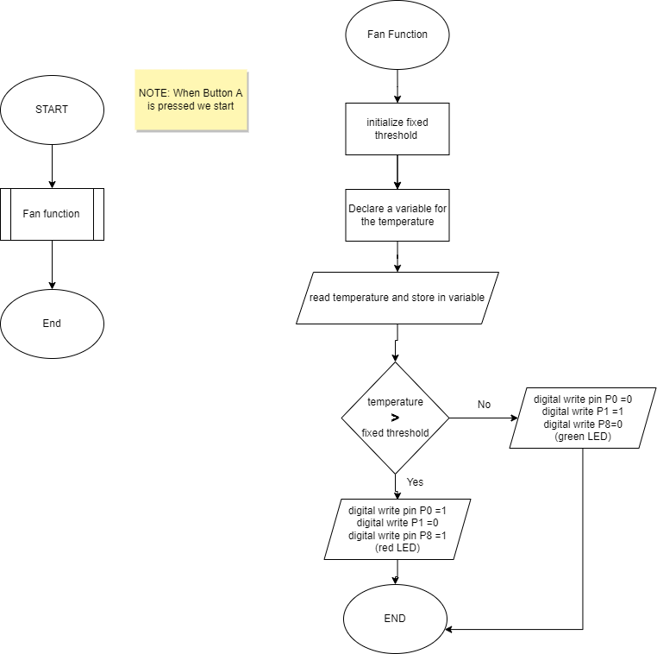

There is always a circle informing you where the algorithm starts. The arrows walk you through to the next steps. The program should take an input pressed button. Next, output the temperature. Finally, the program should end. Since, the program contains a function, the rectangle with the lines within it represents a function.

Build the Circuit:
  - Materials Required:
- Edge I/O Adapter for micro:bit
- Micro:bit battery pack (2xAA or 2xAAA)
- Two Crocodile clip wires
- Eight jumper wires
- 5V high/low level trigger relay
- One Crocodile clips
- DC Motor
- Fan
- Two LEds (red and green)
- Two resistors

  - Hardware Hookup:
Contact from Relay | Connection to Edge I/O adapter | Jumper Wire
VCC | 3V | Any color wire (ex: red)
IN | P8 | Any color wire (ex: yellow)
GND | GND (blue negative line ) | Any color Wire (ex: black)

Contact from Relay | Connection to fan | Jumper Wire
COM | Black crocodile clip | Any color wire (ex: black)
Black wire from COM on relay | Black wire on fan | Black crocodile clip
NO | White Crocodile clip wire | Any color wire (ex: blue)
Blue wire from NO on relay | GND (on breadboard) (blue negative line) | White crocodile clip
Not on relay (on breadboard) (red positive line) | Red wire on fan | Red crocodile clip

Contact from  Edge I/O adapter | Connection to Breadboard | Connector
P0 | Check instruction 1 (ex: a17) | pin wire
P1 | Check instruction 2 (ex: a16) | pin wire
GND (ground) | GND (blue negative column) | pin wire
 | Check instruction 3 (ex: 17e & 18e) | Red LED
 | Check instruction 4 (ex:  18d & blue negative) | Resistor
 | Check instruction 3 (ex: 15e &16e) | Green LED
 | Check instruction 4(ex:15d & blue negative) | Resistor

  - Instructions:
- Can be placed anywhere on breadboard from column a-e and row 1-30 or use example in chart.
- Can be placed anywhere on breadboard except the same row as last pin wire or use example in chart.
- The longer leg(anode) of LED must be on the same row as the pin wire and the shorter leg(cathode) of LED must be the same row as the resistor or use example in chart.
- Must be on blue negative column and on the same as led or use example in chart.
- Connect battery pack to Edge I/O adapter

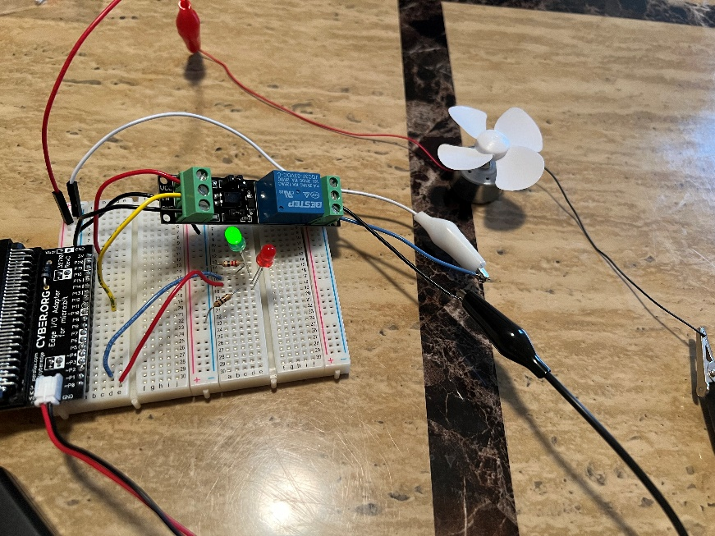

Let’s Start Programming!

Step 1: Getting Started
This program basically is using the same blocks from the temperature fan controller program and placing it into a function. To do this, press the function tab to create a function and name it “Fan Function”. Next, place all recent block code into the function block. Finally, click the function tab again and grab the call fan function block and place it in a on button pressed block.

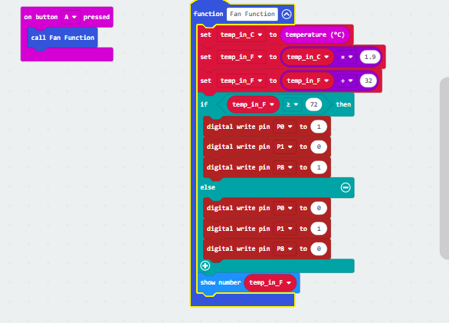

Step 2: Selection Changes
Certain changes can be made within the “on button pressed” block by choosing between A, B, or A+B which means we can determine if we would like to change the temperature when button A is pressed on the microbit, button B, or Both buttons with A+B. The threshold value can also be changed by entering a number in the text box.

Step 3: Test your Program using the Emulator
Step 4: Download the Program
Step 5: Connect to your micro:bit
Step 6: Running the Program on the micro:bit

Congratulations!
You have created your Fan function program!!

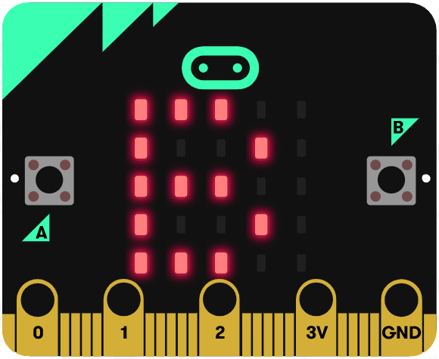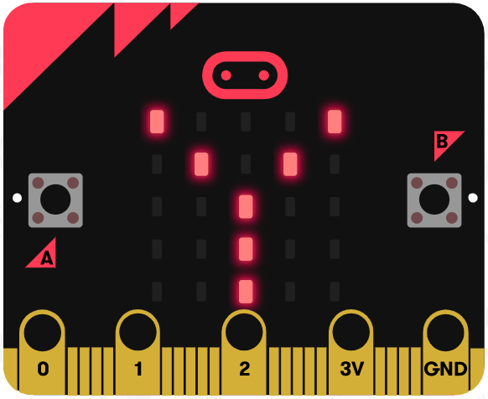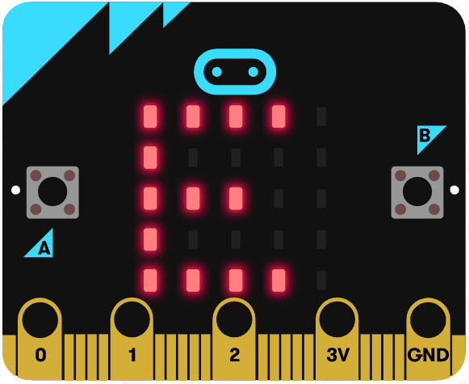

References
Flowchart tool: https://www.draw.io/

