CS Making with Micro:bit
Repeated subtraction using a loop

Problem statement:

Create a program that will compute k where k = a modulo b. Use a loop.

Program design:

We need to perform following tasks in our program based on the problem statement.
- Create and initialize variables for the operands
- Use button A to input the left operand
- Use button B to input the right operand
- Use the button combination A and B to compute the modulo (remainder)
- Reset the variables to zero and reset the screen when the Micro:bit is shaken

Here is our plan as a picture:
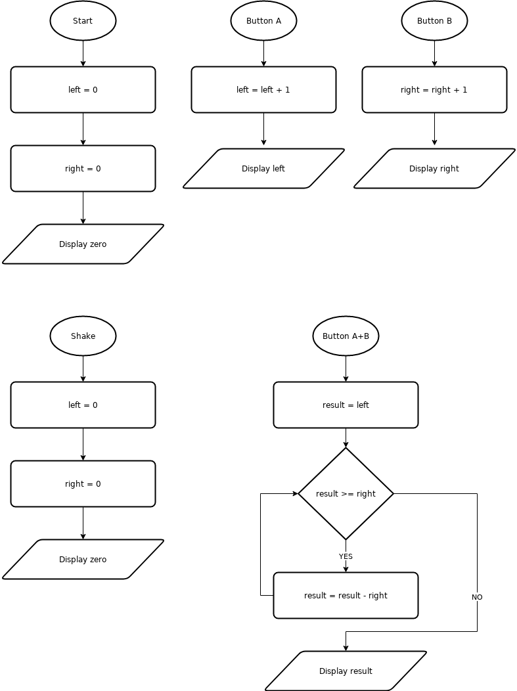

Now we are ready to turn our design into a program.

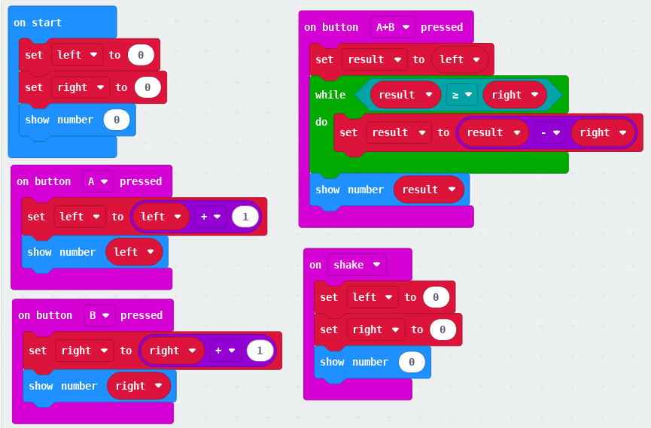

DLCS Standards
6th grade: Computational Thinker #6
7th grade: Computational Thinker #5 and #8
8th grade: Computational Thinker #2 and #3

