Program #2 – Making with Micro:bit
Blink a LED

Problem statement:

Make a circuit and create a program that will blink a LED on and off. The LED should be on for one half of a second and then off for one half of a second. The LED will blink continuously until the Micro:bit is turned off.

Program design:

We need to perform four tasks in our program based on the problem statement.
#1 Turn the LED on
#2 Wait one half of a second
#3 Turn the LED off
#4 Wait one half of a second

Here is our plan as a picture:
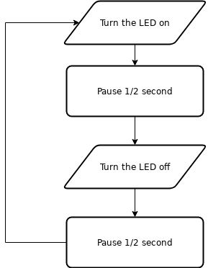

Now we are ready to turn our design into a program.

(program on next page)
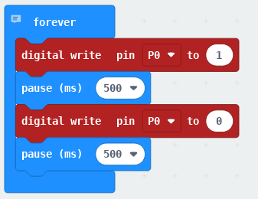
Here is a picture of the circuit.

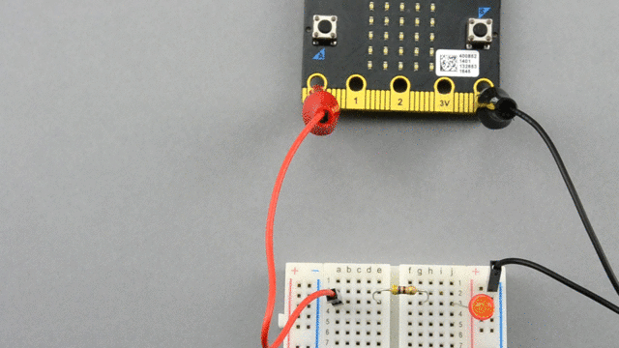

DLCS Standards
6th grade: Computational Thinker #6
7th grade: Computational Thinker #5 and #8
8th grade: Computational Thinker #2 and #3

